

A

PROJECT REPORT

ON

**“IPL Fan Engagement Analysis”**

##### SUBMITTED TOWARDS THE

##### FULFILLMENT OF THE REQUIREMENTS OF

##### **Bachelor of Technology in**

##### **Computer Science & Engineering**

##### By

##### **Nazarene Mustoor Enroll. No: A80105220088**

##### 

**Under the Guidance of**

**Dr. Rika Sharma**



**DEPARTMENT OF COMPUTER SCIENCE ENGINEERING**

AMITY SCHOOL OF ENGINEERING & TECHNOLOGY

**AMITY UNIVERSITY CHHATTISGARH**

RAIPUR- 493225

Batch 2020-2024



**Amity School of Engineering and Technology**

**Department of Computer Science & Engineering**

**CERTIFICATE**

This is to certify that the Project Entitled

**IPL Fan Engagement Analysis**

Submitted by

**Nazarene Mustoor Enrollment No: A80105220088**

is a bonafide work carried out by students under the supervision of **Dr. Rika Sharma** and it is submitted towards the partial fulfillment of the requirement of Bachelor of Technology (Computer Science & Engineering) Dissertation Project.

### Dr. Rika Sharma Mr. Ankit Mishra

Internal Guide Project Guide

Dept. of Computer Science & Engg. Dept. of Computer Science & Engg.

**Dr. Surendra Rahmatkar**

Director

Amity School of Engineering & Technology

### Signature of Internal Examiner Signature of External Examiner

**ACKNOWLEDGMENT**

I would like to express my sincere gratitude to all those who supported and guided me throughout the completion of this thesis.

Firstly, I am deeply thankful to my advisor, Dr. Rika Sharma, whose expertise, encouragement, and invaluable feedback were instrumental in shaping this research.

Special thanks to my peers and colleagues, whose discussions and collaborative spirit provided a stimulating environment for academic growth.

I would also like to acknowledge my family and friends for their unwavering support and encouragement throughout this journey.

This work is a culmination of collective effort and dedication, and I am deeply appreciative of everyone who contributed to its success.

**Nazarene Mustoor**

(B.Tech - CSE)

**TABLE OF CONTENTS:**

Abstract

1. Introduction
   1. Background
   2. Significance
   3. Objectives
   4. Research Questions
2. Literature Review
   1. Existing Research
   2. Gaps
3. Methodology
   1. Data Collection Methods
   2. Sentiment Analysis
   3. Statistical Methods
4. Analyze and Results
   1. Exploratory Data Analysis
   2. Conduct T-Test
   3. Results
5. Discussion
   1. Interpretation of Results
   2. Implications of Findings
6. Conclusion
   1. Summarizing Key Findings
   2. Future Research
   3. Reflection on Limitations

References

**ABSTRACT**

This thesis investigates the correlation between fan engagement intensity during critical moments of Indian Premier League (IPL) matches and the performance of individual players. Critical moments include close finishes, pivotal overs, key wickets, and match-turning events. Utilizing Python for data scraping and analysis, we categorized fan engagement into high and low intensity groups and employed T-tests to compare player performances across these groups. The study reveals a significant correlation between heightened fan engagement and improved player performance in high-pressure situations, suggesting that the external environment plays a pivotal role in influencing player outcomes. The findings contribute to the existing literature on sports psychology and fan behavior, offering valuable insights for team management, broadcasters, and league organizers. This research underscores the importance of understanding the dynamics between fans and players, paving the way for further studies on the impact of audience engagement on athletic performance.

Chapter -1

**INTRODUCTION**

* 1. **BACKGROUND**

The Indian Premier League (IPL), popularly known as the TATA IPL due to sponsorship agreements, is a prominent men's Twenty20 (T20) cricket league held annually in India. Launched by the Board of Control for Cricket in India (BCCI) in 2007, the league comprises ten franchise teams representing various states or cities. Typically, the IPL is scheduled between March and May each year, coinciding with an exclusive window in the International Cricket Council (ICC) Future Tours Programme. This scheduling ensures minimal international cricket tours during the IPL season, highlighting its significant impact on the global cricket calendar.

Globally, the IPL stands out as the most popular cricket league, ranking sixth in average attendance among all sports leagues in 2014. In 2010, it made history by becoming the first sporting event to be broadcast live on YouTube. The league's success has inspired the creation of other sports leagues in India, fostering a broader sports culture within the country. By 2022, the IPL's brand value had soared to ₹90,038 crore (US$11 billion), reflecting its immense popularity and economic impact. The BCCI reported that the 2015 IPL season contributed ₹1,150 crore (US$140 million) to India's Gross Domestic Product (GDP). The league's valuation continued to rise, reaching US$10.9 billion by December 2022, marking a 75% increase in dollar terms since 2020. The 2023 IPL final set a new record as the most streamed live event on the internet, attracting 32 million viewers.

In a landmark deal in 2023, the IPL sold its media rights for the next four seasons for US$6.4 billion to Viacom18 and Star Sports, valuing each match at $13.4 million. As of 2024, the IPL has completed seventeen seasons, with the Kolkata Knight Riders emerging as the champions of the latest season, defeating the Sunrisers Hyderabad in the final.

The inception of the IPL was partly a response to the creation of the Indian Cricket League (ICL) by Zee Entertainment Enterprises in 2007. The ICL was not recognized by the BCCI or the ICC, leading to tensions within the cricketing community. The BCCI reacted by increasing prize money for its domestic tournaments and imposing lifetime bans on players who joined the ICL, which it deemed a rebel league.

Following India's victory in the 2007 T20 World Cup, the BCCI announced the establishment of the IPL on 13 September 2007. This franchise-based T20 competition aimed to revolutionize cricket in India. The inaugural season was planned for April 2008, beginning with a grand ceremony in New Delhi. BCCI Vice-President Lalit Modi, the driving force behind the IPL, outlined the tournament's structure, including its format, prize money, franchise revenue system, and squad composition rules. Managed by a seven-man governing council, the IPL was also set to serve as a qualifying mechanism for the Champions League Twenty20.

The franchises' ownership was determined through an auction held on 24 January 2008. The reserve prices for the eight original franchises totaled $400 million, but the auction ultimately generated $723.59 million, highlighting the high demand and financial potential of the league. The first season, which kicked off in April 2008, featured teams such as Chennai Super Kings (CSK), Mumbai Indians (MI), Delhi Daredevils (DD), Kings XI Punjab (KXIP), Deccan Chargers (DC), Rajasthan Royals (RR), Kolkata Knight Riders (KKR), and Royal Challengers Bangalore (RCB).

The rivalry with the ICL did not last long, as the BCCI's stringent measures and strategic moves led to the downfall of the ICL, which ceased operations in 2009. The IPL, on the other hand, continued to grow in stature and popularity, becoming a cornerstone of global cricket.

The IPL's journey from its inception to its current status as a cricketing powerhouse is a testament to its innovative format and commercial success. The league has not only provided a platform for domestic and international players to showcase their talents but has also significantly contributed to the economic and cultural landscape of India. The annual event captures the attention of millions of fans worldwide, blending sports with entertainment and commercial opportunities.

In conclusion, the IPL's foundation and evolution reflect a strategic response to challenges and opportunities within the cricketing world. Its success story is marked by record-breaking viewership, substantial economic contributions, and the establishment of a new paradigm in sports leagues. As it continues to evolve, the IPL remains a dynamic force in the realm of cricket, setting new benchmarks for sports entertainment globally.

* 1. **SIGNIFICANCE**

The Indian Premier League's (IPL) meteoric rise in brand value and commercial appeal highlights its profound impact on the economy, tourism, digital landscape, and job market. Since its inception, the IPL has transcended its identity as a mere sports league, evolving into a major economic entity. Valued at US$10.7 billion, the IPL's explosive growth of 28% according to Brand Finance underscores its commercial prowess, making it an attractive platform for brands to engage with India’s vast consumer base.

Since its establishment in 2008, the IPL has not only popularized cricket but also revolutionized its economic landscape. The league has redefined how cricket is played, viewed, and commercialized in India. It has emerged as a premier sporting and marketing platform, significantly impacting Indian cricket. This premier cricket tournament has not only entertained millions of fans but has also been instrumental in the development of the sport within the country. The IPL's influence is evident across multiple dimensions. From a sporting perspective, it provides a platform for both domestic and international players to compete at the highest level. The league showcases high-quality cricket, filled with thrilling matches, intense rivalries, and outstanding performances. It also serves as a breeding ground for young talent, offering emerging players the chance to display their skills.

The IPL has become a vital platform for nurturing young cricketing talent. Domestic players have the opportunity to play alongside established international stars, which helps them gain invaluable experience and exposure. For many aspiring cricketers, the IPL acts as a springboard to national representation. Numerous players have achieved prominence through their exceptional performances in the league. Additionally, the IPL has bolstered domestic cricket infrastructure and grassroots development, fostering a competitive cricket ecosystem in India.

The IPL has also significantly boosted tourism in India. The tournament attracts cricket enthusiasts from around the globe, leading to a surge in tourists during the IPL season. International visitors travel to India specifically to watch live matches, contributing to the tourism economy through bookings of flights, accommodations, and local transportation. With matches held across various Indian cities, fans are encouraged to explore different regions, experience local culture, and visit tourist attractions. The hospitality industry sees increased demand for hotel rooms, as fans, players, and media personnel require accommodations during the matches. Overall, the IPL acts as a major catalyst for tourism, promoting India as a vibrant destination for cricket and travel enthusiasts.

Advertising and sponsorship opportunities are extensive within the IPL. The league's vast viewership and dedicated fanbase make it a highly desirable platform for brands to reach a wide audience and establish strong brand associations. Brands can also become title sponsors of the entire tournament, with their names prominently featured in the official tournament name, such as “The (Brand Name) Indian Premier League.” Each IPL team also secures sponsorships from companies, who then have their logos displayed on team jerseys, helmets, and merchandise. These advertising and sponsorship opportunities significantly contribute to the league’s revenue generation while providing brands with a powerful marketing platform.

The IPL's commercial success has been unprecedented. The league has attracted substantial investments from corporate sponsors, broadcasters, and franchise owners. The IPL’s broadcast rights have consistently commanded enormous sums, boosting the revenues of the BCCI and other cricket boards. The league's success is a testament to its robust commercial framework, which has made it a lucrative venture for all stakeholders involved.

Economically, the IPL has had a considerable impact on the host cities, creating numerous job opportunities, enhancing tourism, and generating revenue for businesses in sectors like sports, hospitality, and entertainment. From 2015 to 2023, the IPL’s contribution to India’s GDP has grown exponentially, highlighting its increasing significance as a major driver of economic prosperity in the country.

The entertainment aspect of the IPL has been a key factor in its massive popularity. The league blends cricket with glamour and Bollywood, creating a comprehensive entertainment package. Cheerleaders, music, and engaging halftime shows enhance the spectator experience. The IPL’s success in engaging fans both in stadiums and through television and digital platforms has set a high standard for other sports leagues.

In summary, the Indian Premier League's influence extends far beyond the boundaries of cricket. It has become a significant economic force, contributing to various sectors such as tourism, advertising, and entertainment. The league's role in promoting young talent, enhancing domestic cricket infrastructure, and boosting the economy underscores its multifaceted impact on Indian society. As the IPL continues to grow, it remains a dynamic and influential entity in the world of sports, consistently setting new benchmarks and driving innovation in cricket and beyond.

* 1. **OBJECTIVES**

Primary Objective

**To analyze the impact of fan engagement on cricket players’ performance in IPL.**

Other Objectives:

• **Assess the Impact of Fan Engagement on Player Performance**: To analyze how varying levels of fan engagement during critical moments of IPL matches affect the performance of individual players.

• **Identify and Categorize Critical Moments in IPL Matches**: To define and classify critical moments such as close finishes, pivotal overs, key wickets, or match-turning events that significantly influence the outcome of the game.

• **Measure and Quantify Fan Engagement Intensity**: To develop and implement a method for quantifying fan engagement intensity using metrics such as social media activity, live match attendance, and viewer ratings.

• **Compare Player Performance in High vs. Low Fan Engagement Scenarios**: To perform a comparative analysis using T-tests to determine statistically significant differences in player performance between high and low intensity fan engagement groups.

• **Investigate the Role of Social Media in Fan Engagement**: To explore the contribution of social media platforms to fan engagement during critical moments of IPL matches and its impact on player performance.

• **Evaluate Psychological and Economic Impacts**: To examine the psychological effects of fan engagement on players and assess the broader economic implications, including ticket sales, merchandise, and advertising revenues.

* 1. **RESEARCH QUESTION**

How does the intensity of fan engagement during critical moments in IPL matches affect the performance of players?

[Critical moments such as close finishes, pivotal overs, key wickets, or match-turning moments.]

Chapter – 2

**LITERATURE REVIEW**

**2.1 EXISTING RESEARCH**

The Influence of Digital and Social Media on Sports

The transformation of the sports landscape through digital and social media is extraordinary. These platforms have revolutionized the way sports are consumed and experienced, providing fans with unprecedented access to their favorite teams and players. Real-time updates and content across various platforms have made it possible for fans to stay constantly connected to the sports world. Teams can now reach a broader and more global audience through digital and social media, significantly extending their reach and influence.

Social media has facilitated the creation of communities of passionate supporters, allowing fans to interact with each other like never before. This digital landscape has opened new avenues for marketing and promotion, offering unique opportunities to engage fans and build loyalty. Additionally, teams have discovered new revenue streams by monetizing their digital content, reaching unprecedented levels of success. Fans today can connect with their favorite teams and athletes around the clock via a variety of digital and social platforms, providing a more intimate experience. This constant connection allows fans to follow their teams and players in ways that were previously impossible.

In the past, if a fan had a question or request for their favorite team, they would have to send a letter or make a phone call, which could take days or even weeks to elicit a response. Social media has dramatically changed this dynamic, enabling fans to reach out to teams and athletes instantly and receive immediate responses. This level of access has strengthened the relationships between fans and the teams they follow, fostering a deeper connection and loyalty.

The high level of fan engagement is evident in how fans use social media to connect with each other and share their thoughts and opinions on the content they are watching. Twitter, for example, has become a hub for live-tweeting television shows, allowing viewers to interact in real-time while watching the same content. This interaction creates a sense of community among viewers, encouraging them to continue watching the show and engage in discussions afterwards. Similarly, Facebook groups and forums dedicated to specific TV shows or movies provide another avenue for fans to connect and discuss their favorite content.

The digital and social media landscape has dramatically changed the way sports are marketed and consumed. Teams now have the ability to engage with a global audience, creating opportunities for international fan bases and expanding their influence beyond local or national boundaries. This global reach has opened new revenue streams and sponsorship opportunities, significantly enhancing the financial stability and profitability of sports organizations.

Marketing strategies have evolved to leverage the unique capabilities of digital and social media. Teams and athletes use these platforms to promote their brands, engage with fans, and deliver targeted marketing campaigns. The ability to reach a specific audience with personalized content has proven to be a powerful tool in building brand loyalty and driving consumer engagement.

Social media also plays a critical role in shaping the narrative around sports. Fans can voice their opinions and share their perspectives on games, players, and events, influencing public perception and media coverage. This democratization of content creation has given fans a more active role in the sports ecosystem, empowering them to contribute to the conversation and shape the narrative.

The monetization of digital content has opened new revenue streams for teams and athletes. By creating exclusive content, offering behind-the-scenes access, and engaging in live interactions, teams can generate income through subscriptions, sponsorships, and advertising. This revenue is crucial in supporting the growth and development of sports organizations, enabling them to invest in facilities, training, and talent development.

Moreover, the integration of digital and social media into sports has enhanced the fan experience. Fans can now access a wealth of information and content about their favorite teams and players, including live scores, statistics, and highlights. Interactive features such as polls, quizzes, and live chats create a more engaging and immersive experience, keeping fans invested in the sport.

The influence of digital and social media extends beyond traditional sports, impacting emerging sports and eSports. These platforms have provided a launchpad for new sports to gain visibility and attract audiences. The ability to reach a global audience through social media has accelerated the growth of niche sports and created opportunities for athletes in less mainstream disciplines to build a following and achieve recognition.

**The 14th Season of IPL and the Evolution of OTT Platforms in India**

The 14th season of the Indian Premier League (IPL) marked a transformative period in the digital landscape, highlighting how cricket, often celebrated like a festival in India, can bridge gaps between countries through digital media. The entertainment industry has always been dynamic, evolving significantly in form and format with each passing decade. Today’s entertainment format, vastly different from previous ones, is continuously expanding, with "over-the-top (OTT)" being the current buzzword. OTT signifies the pervasive nature of entertainment, and its adoption has brought radical transformations to the industry. Initially, OTT platforms were primarily used for watching movies, and they were accessible only to those who could afford the high subscription costs, leaving many middle-class individuals reliant on traditional television channels. However, the entry of Reliance Jio revolutionized this scenario by offering affordable data packages, effectively bridging the gap between audiences and entertainment through collaborations with platforms like Disney+ Hotstar (Business Today, 2018).

According to Das Gupta (2019), Star India secured the IPL global media rights for Rs. 16,347 crores over five years, indicating a significant shift in how viewers consume cricket. An interesting trend emerged with a notable increase in the time spent watching matches on OTT streaming channels without negatively impacting IPL TV viewership. This trend suggests the influx of new viewers. In 2019, consumers used Disney+ Hotstar and its digital channels to watch IPL matches for a staggering 15 billion minutes, while TV viewership remained stable at approximately 110 billion minutes. Data usage patterns further illustrated this shift; previously, the high cost of data at around Rs. 185 per GB made streaming matches unaffordable for many. However, Jio's introduction of significantly cheaper data packs, reducing costs by up to 95% to less than Rs. 10 per GB, changed the game. This price reduction allowed more consumers to stream matches affordably, resulting in a noticeable increase in digital viewing time, projected to rise by 20-25% of overall viewing minutes (TV and digital). Although the global pandemic in 2020 delayed the IPL, it heightened viewer anticipation and excitement.

Kumari (2020), in her research on the growth of OTT video services in India, elaborates on content consumption patterns, viewing habits, barriers to adopting OTT services, and the future prospects of OTT platforms in the country. She identifies several factors contributing to the rise of OTT platforms, including the preferred mediums for content consumption, the convenience offered by these platforms, and the technological advancements driving their growth. Kumari concludes that the future of OTT services in India is promising, as both current users and non-users express willingness to adopt these services in the future.

The evolution of the IPL and its integration with digital media platforms like Disney+ Hotstar exemplify the broader trends in the entertainment industry. The IPL’s ability to attract millions of viewers both on television and digital platforms underscores the changing nature of content consumption. Fans now enjoy unprecedented access to live sports, replays, and exclusive content, all facilitated by affordable data plans and the widespread availability of smartphones and internet services. This shift has not only democratized access to premium content but has also created new revenue streams for broadcasters and OTT platforms.

The collaboration between the IPL and digital media giants highlights the synergy between sports and technology. As digital platforms continue to innovate, the quality and accessibility of content improve, offering viewers an enriched experience. The availability of live-streaming options, interactive features, and on-demand content caters to the diverse preferences of a modern audience, making sports more engaging and inclusive.

Furthermore, the pandemic-induced delay of the IPL in 2020 amplified the role of digital media in keeping fans connected and engaged. The anticipation and subsequent resumption of the league demonstrated the resilience of sports entertainment and its ability to adapt to unprecedented challenges. Digital platforms played a crucial role in maintaining fan engagement through social media interactions, virtual events, and exclusive online content, ensuring that the excitement and enthusiasm for the IPL remained high.

Cricket and the Impact of Live Scores on Fan Engagement

Cricket, often likened to a religion in many countries, holds a special place in the hearts of millions globally. It is more than just a sport; it is an emotion that brings people from diverse backgrounds together. With technological advancements, cricket fans now have the luxury of following live cricket scores from virtually anywhere and at any time. This ability to access real-time updates has significantly enhanced fan engagement and the overall cricket-watching experience. This article delves into the impact of live cricket scores on fan engagement and experience, exploring the various elements that make this form of interaction compelling.

Cricket is an integral part of the culture for millions of enthusiasts worldwide. Traditionally, following cricket matches meant relying on television or radio broadcasts to stay updated on scores and events. However, the digital revolution has transformed fan interaction with the game, and the emergence of live cricket scores has redefined fan engagement. Over the years, the concept of live cricket scores has evolved significantly. Initially, fans could access score updates through Teletext services and later through websites offering ball-by-ball commentary. Today, dedicated mobile applications and websites provide real-time scores, statistics, player information, and much more, bringing fans closer to the game than ever before.

One of the most significant advantages of live cricket scores is the convenience they offer. Whether at home, work, or on the go, cricket enthusiasts can easily access match updates through their smartphones or laptops. This accessibility ensures that fans can stay connected with the game, even if they cannot watch it live on television. Live cricket scores inject an element of excitement and anticipation into the game. Every delivery can change the course of the match, and fans eagerly await each score update to experience the thrill of the game unfolding in real-time. The constant flow of information adds to the drama, making the experience akin to being present at the stadium.

Social media platforms have become virtual stadiums where cricket fans gather to discuss and celebrate the game. Live cricket scores are widely shared on platforms like Twitter, Facebook, and Instagram, creating a buzzing online community of cricket enthusiasts. This social media engagement allows fans to interact with one another, share opinions, and celebrate their favorite players’ achievements. The rise of fantasy cricket leagues and online betting platforms has further heightened the significance of live cricket scores. Fans actively participate in fantasy leagues, where they create virtual teams based on real players’ performances. The scores of these players in actual matches directly impact the fantasy league standings, adding a new dimension of excitement for fans.

With live cricket scores available at their fingertips, fans watching the match on television or in stadiums enjoy an enhanced viewing experience. They can cross-verify the information on their screens, gain insights into player statistics, and stay updated on other concurrent matches, enriching their overall understanding and enjoyment of the game. Live cricket scores take fans on an emotional rollercoaster ride. Each boundary or wicket triggers bursts of joy or anxiety, depending on which team they support. The adrenaline rush during close encounters and the elation of victory or heartbreak of defeat further strengthen the emotional connection between fans and the game.

Live cricket scores help build a sense of community among fans of the same team. They unite under a common cause and celebrate their team’s successes together. This sense of belonging fosters loyalty and keeps fans invested in the sport, even during difficult times. Fans actively participate in cheering for their teams online during live matches. Hashtags related to the teams and players trend on social media platforms, and fans express their unwavering support through creative posts and memes. This virtual cheerleading adds an extra layer of motivation for players and strengthens the bond between fans and their favorite teams.

Live cricket scores have broken geographical barriers, allowing the game to reach a global audience. Cricket enthusiasts from different countries follow matches from around the world, fostering a diverse and vibrant cricketing community. However, while live cricket scores enhance fan engagement, they can also exert pressure on players. Every move of the players is closely scrutinized, and poor performances can result in harsh criticism from fans, affecting players’ mental well-being. The availability of live scores raises the question of whether it affects live match attendance and television viewership. Research suggests that while some fans prefer real-time updates, others still cherish the experience of watching matches live, creating a delicate balance between the two.

The constant pursuit of innovation has led to the development of cutting-edge technologies in live scoring. From AI-driven analytics to augmented reality experiences, these advancements continue to elevate the fan experience.

**2.2 GAPS IN LITERATURE**

1. **Limited Focus on IPL's Digital Media Impact**: The current literature discusses the impact of digital media on sports broadly but does not provide a detailed examination of how digital and social media specifically affect the IPL. My project will address this by exploring the unique ways in which digital platforms have transformed IPL fan engagement and player performance.
2. **Insufficient Analysis of Real-time Fan Engagement**: Although there is mention of real-time updates enhancing fan experience, there is a lack of in-depth analysis on how these updates impact fan engagement during critical IPL moments. My study aims to fill this gap by focusing on fan interactions during pivotal match events like close finishes and key wickets.
3. **Lack of Empirical Data on Fan Engagement and Player Performance**: There is a need for more empirical data that links fan engagement directly to player performance during IPL matches. My project will provide this data through quantitative analysis, utilizing t-tests to explore the correlation between fan engagement and individual player performance.
4. **Overlooked Economic and Social Impact**: While the literature touches on the economic contributions of the IPL and the role of OTT platforms, it does not delve deeply into how these factors influence fan behavior and player performance. My research will offer insights into the economic and social aspects that drive fan engagement and how these factors impact the game.
5. **Minimal Examination of Virtual Communities**: Although social media's role in connecting fans is mentioned, there is limited exploration of how virtual communities of IPL fans interact and influence each other during critical moments. My project will analyze these interactions to provide a clearer understanding of online fan communities.
6. **Absence of Comparative Analysis**: There is no comprehensive comparative analysis between periods of high and low-intensity fan engagement. My study will address this by using t-tests to compare these periods and analyze their correlation with player performance.
7. **Unexplored Future Trends**: Current literature discusses present trends but does not sufficiently project future developments in digital media's impact on sports, particularly the IPL. My project will identify potential future trends and their expected impact on fan engagement and player performance.

Objectives to Address Gaps

1. To examine how digital and social media specifically influence IPL fan engagement and player performance.
2. To investigate the intensity of fan engagement during critical IPL match moments and its correlation with player performance.
3. To provide empirical data linking fan engagement to individual player performance using t-tests and other statistical methods.
4. To analyze the dynamics of virtual communities of IPL fans and their influence on each other during critical match moments.
5. To perform a comparative analysis between high and low-intensity fan engagement periods and their correlation with player performance.
6. To identify and project future trends in digital media's impact on IPL fan engagement and player performance.

Chapter – 3

**METHODOLOGY**

**3.1 DATA COLLECTION METHODS**

Tech Stack :

The technical tools and methodologies employed in this study are critical for data collection, analysis, and visualization. The primary tools used include:

* Python Programming Language: Python was chosen due to its extensive libraries and frameworks that facilitate data manipulation, statistical analysis, and visualization.
* Jupyter Notebook: Jupyter Notebook was used as the interactive development environment for writing and running code, making it easier to document the analysis process.
* Libraries used:
* BeautifulSoup and requests : This was used for web-scraping to collect real- time data of matches which had critical moments, information about the matches, and the players involved.
* Selenium and Webdriver: This library was used for scraping social media data such as tweets and posts from Twitter (X) and Instagram.
* Vader from ntlk: Used for sentiment analysis of twitter and instagram data.
* Pandas: Pandas was used for data manipulation and preprocessing, providing efficient data structures and data analysis tools.
* NumPy: NumPy was utilized for numerical operations on the data.
* SciPy: SciPy was used to perform statistical tests, including the t-tests.
* Matplotlib, Plotly, and Seaborn: These libraries were used for data visualization, helping to create plots and graphs to represent the data and analysis visually.
* Power BI and DAX: This was used to create the dashboard.

Data Collection Method:

* Critical Moments Data
* Player Statistics
* Fan Engagement Data

Critical Moments Data:

Web - Scraping using BeautifulSoup and Requests

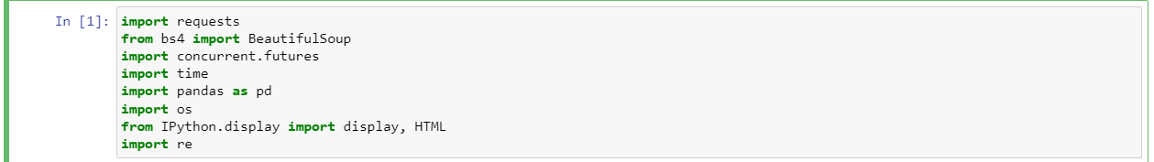

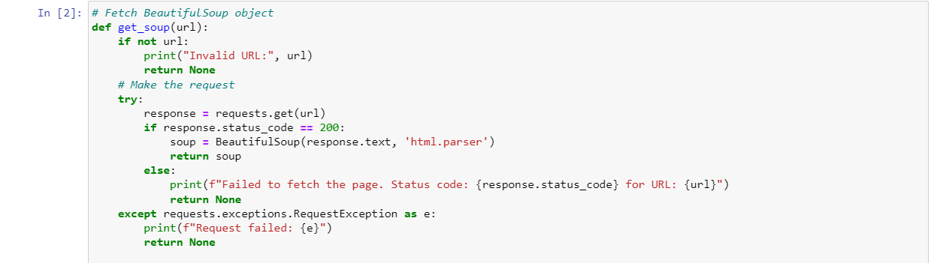

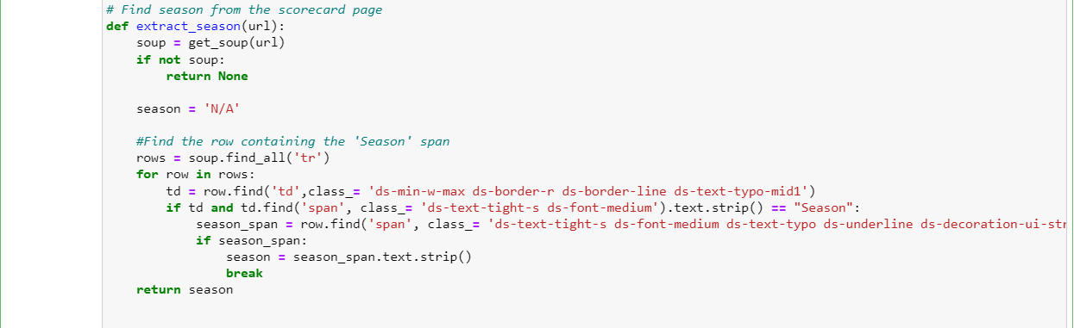

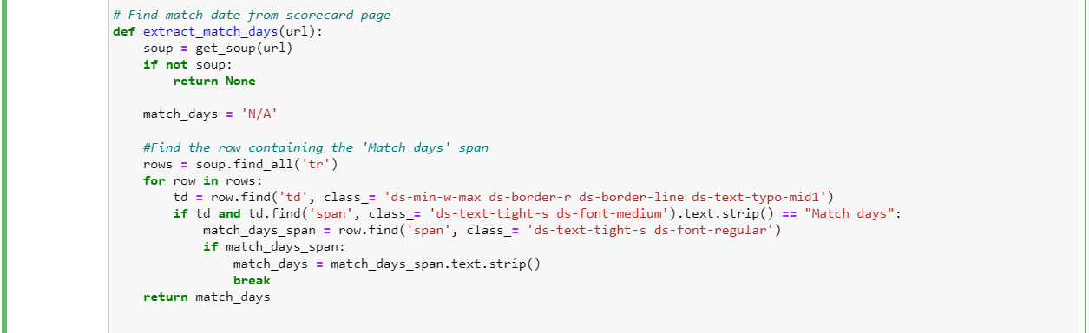



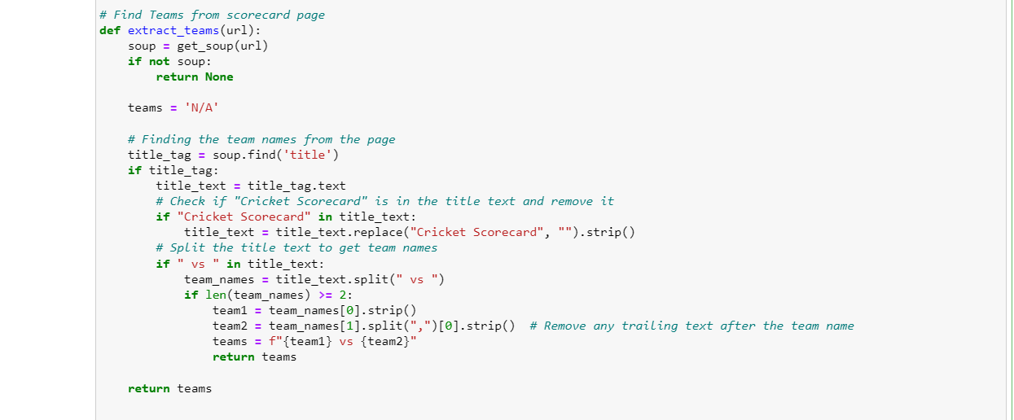

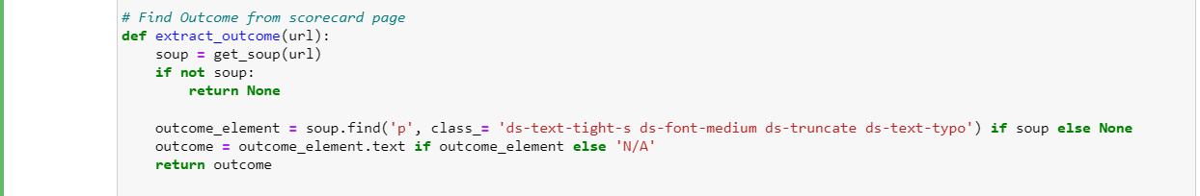

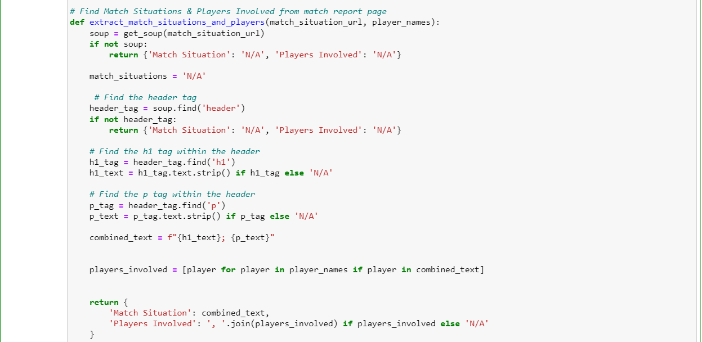

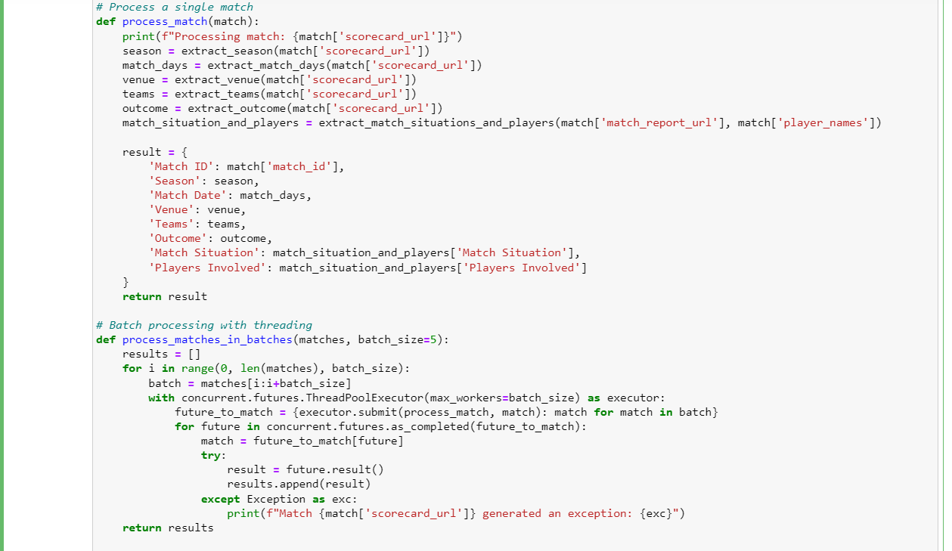

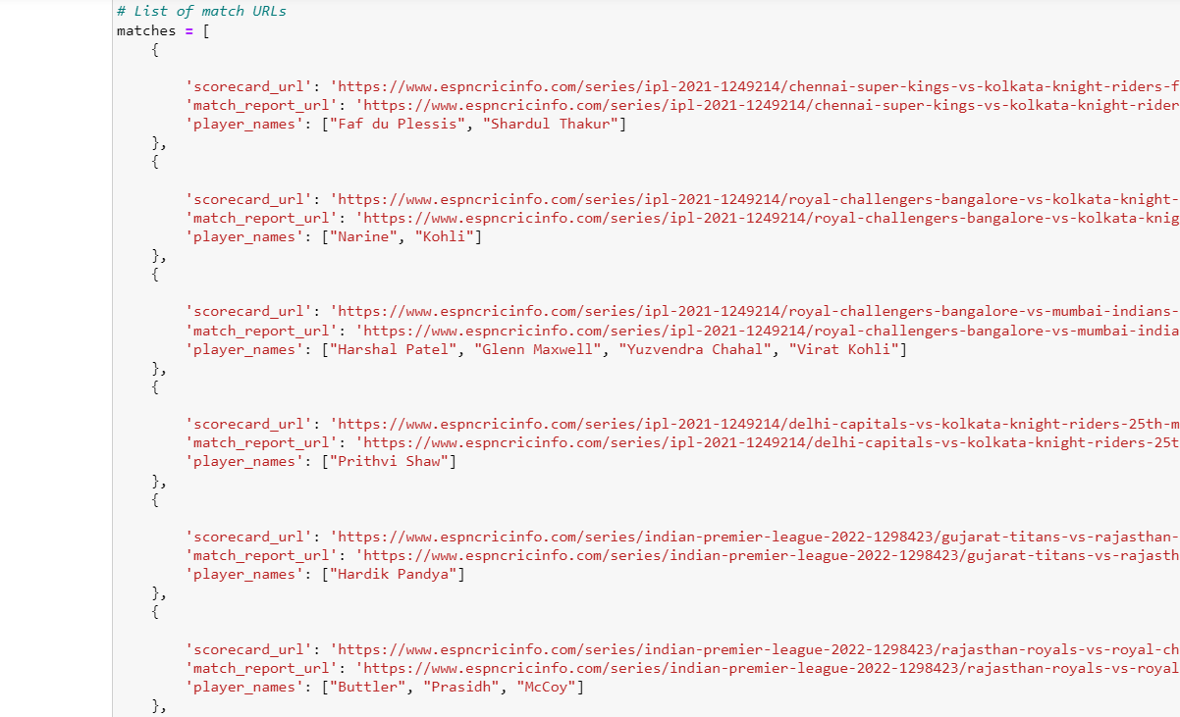

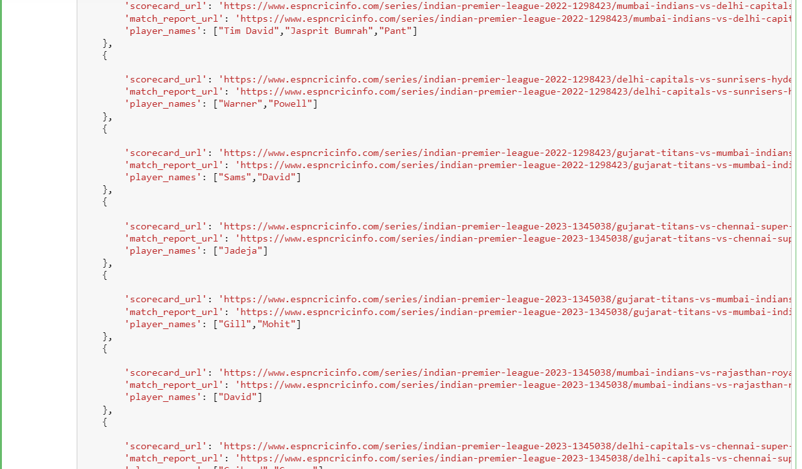

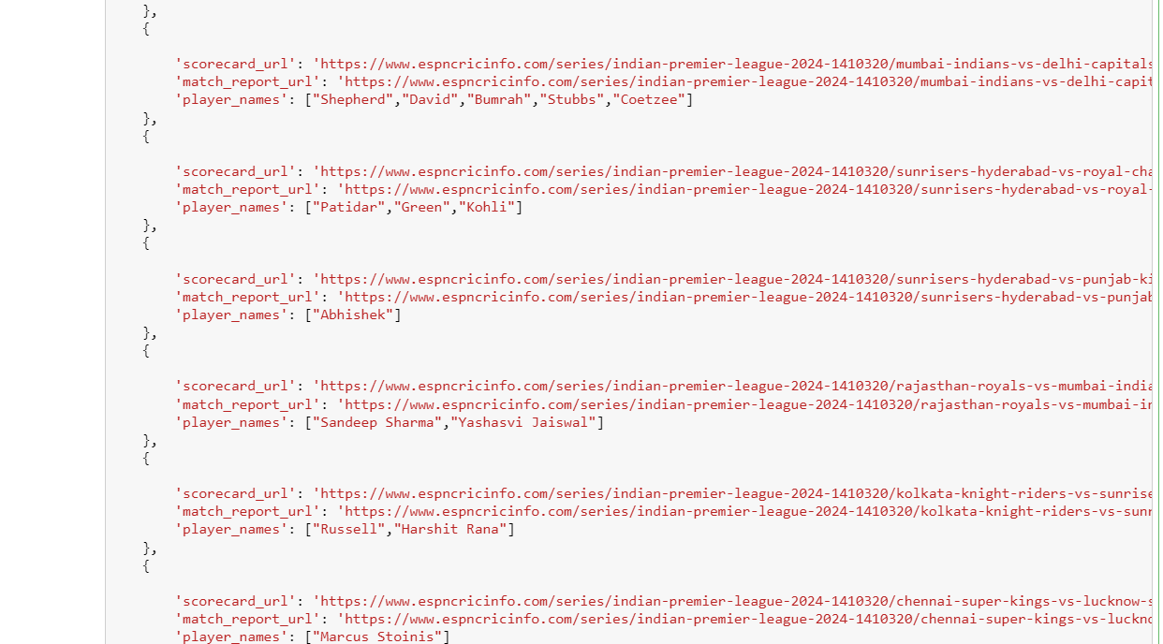

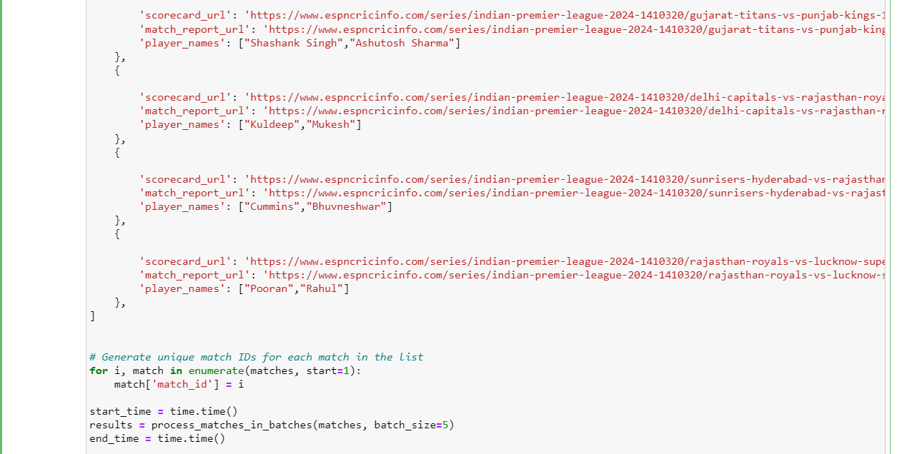

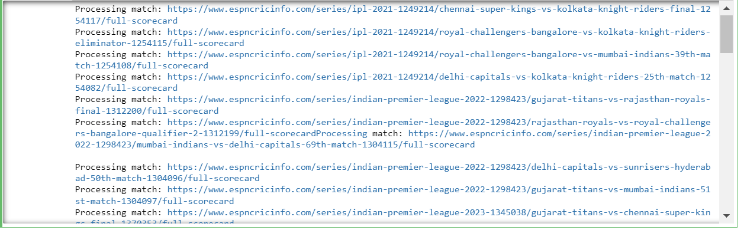

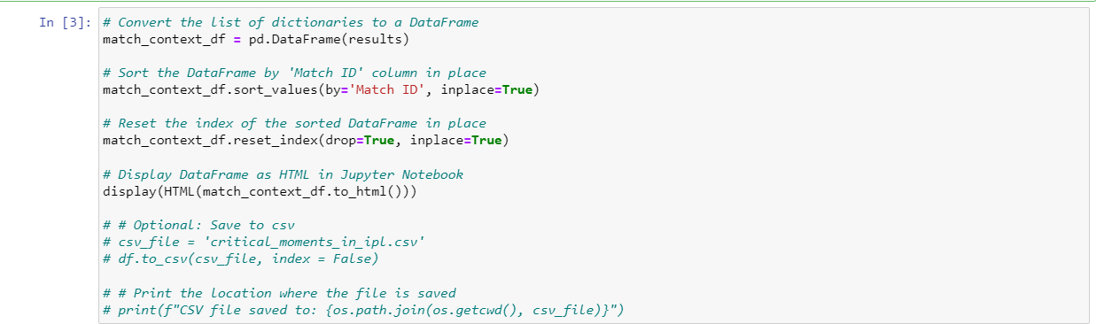

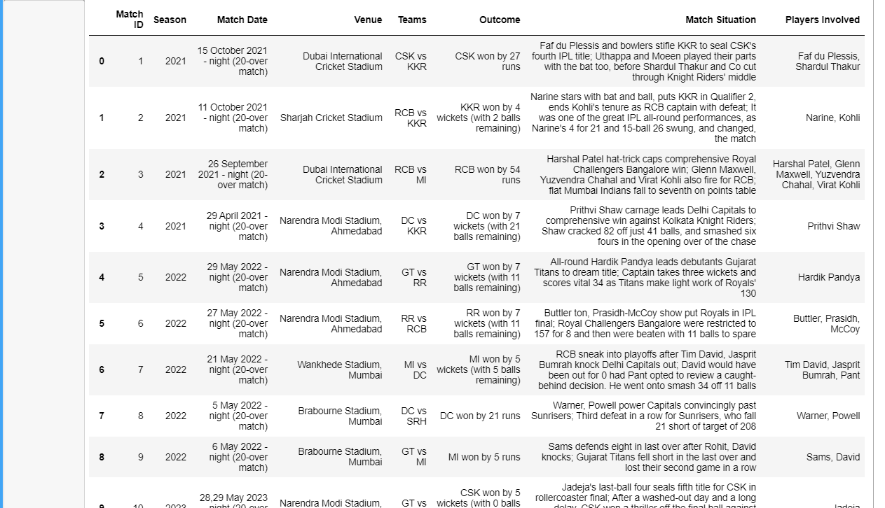

Player Statistics:

Web – Scraping using BeautifulSoup and Requests

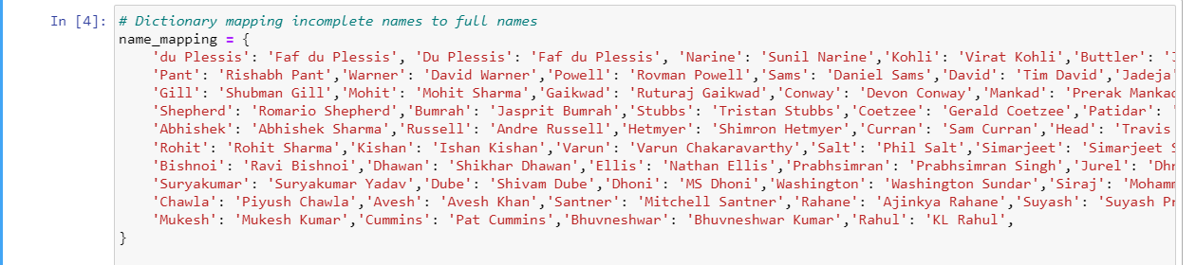

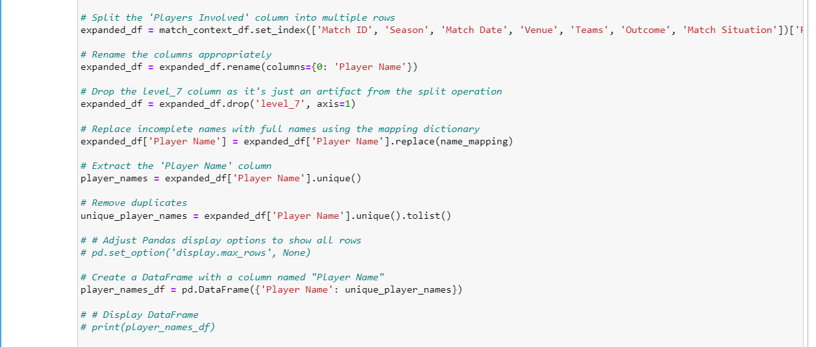

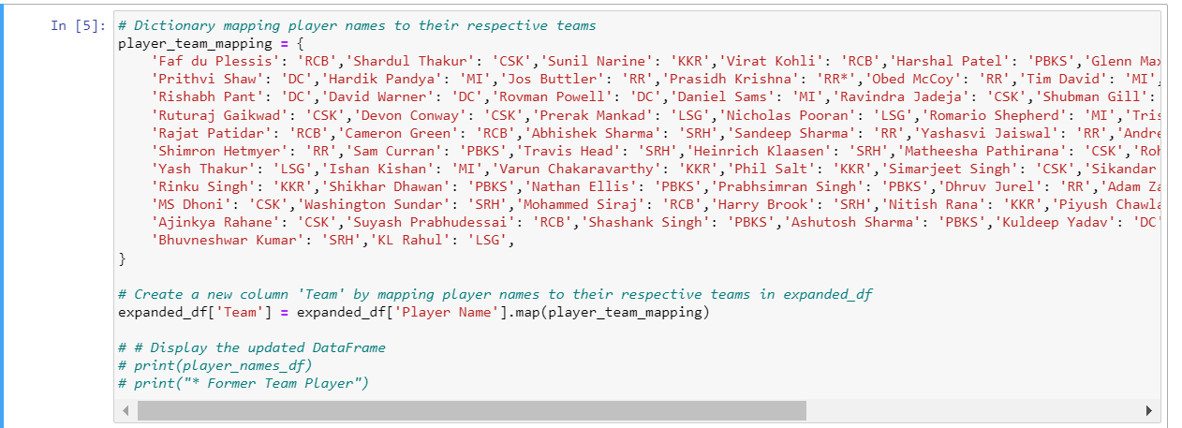

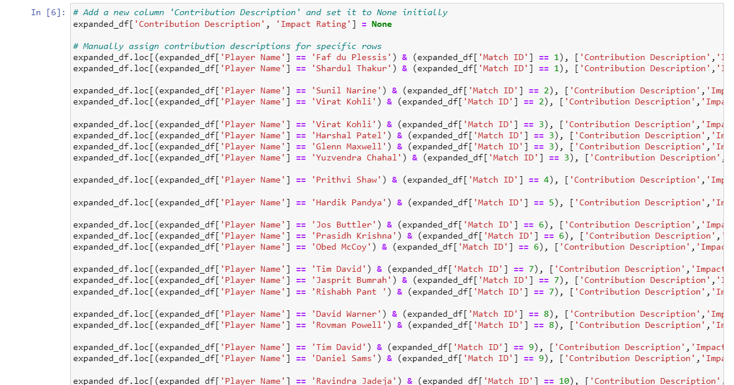

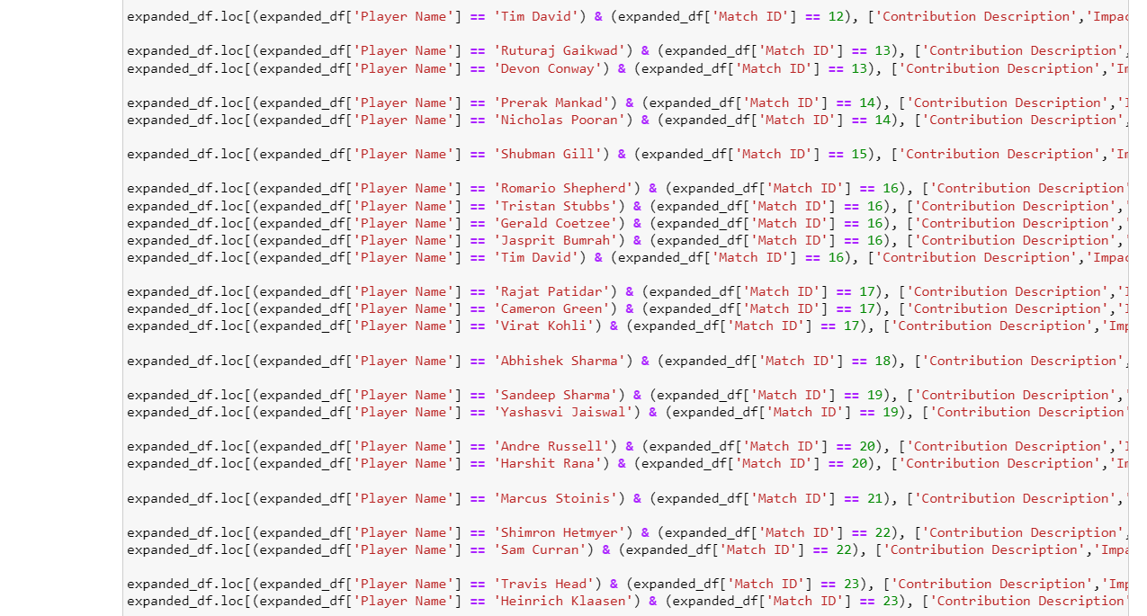

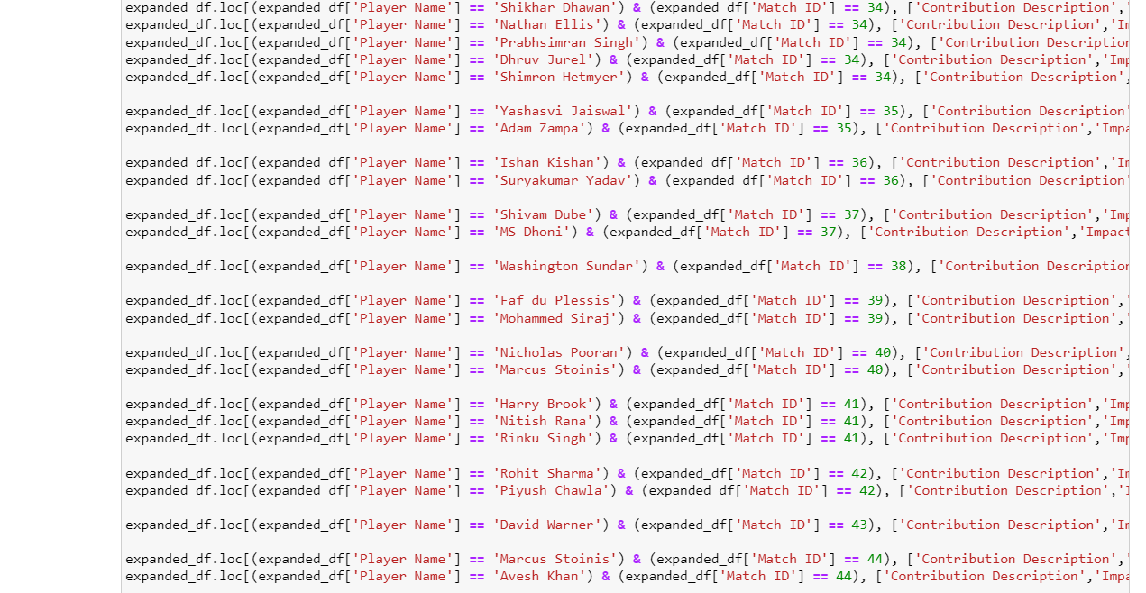

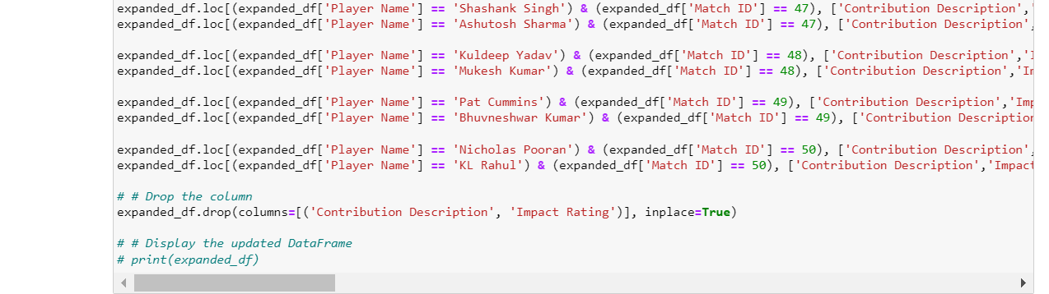

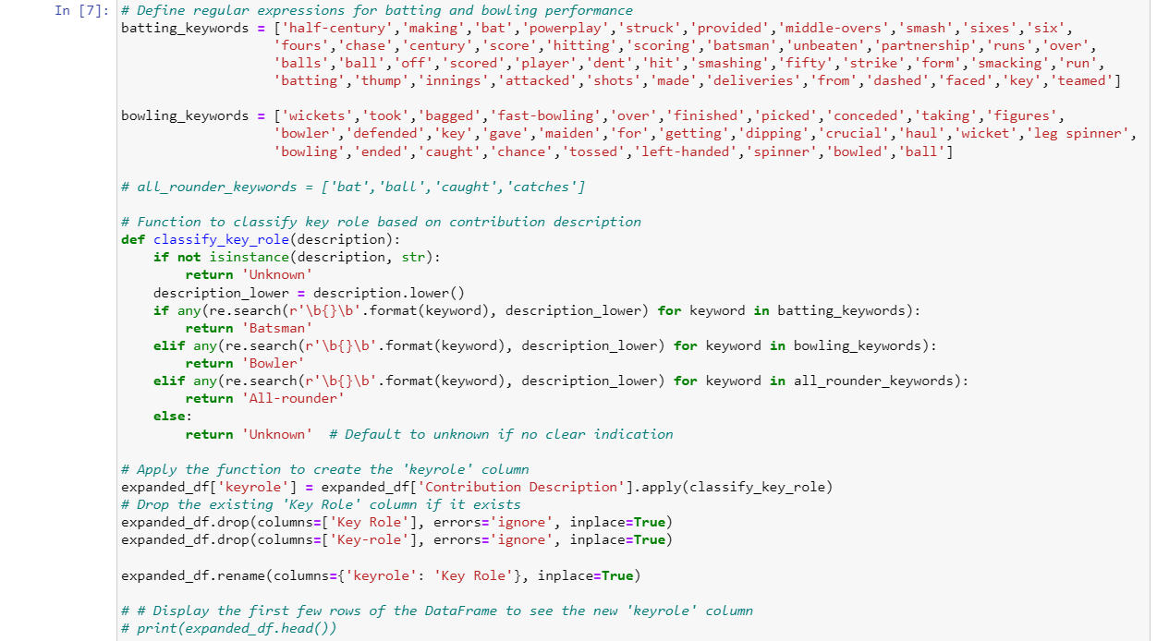

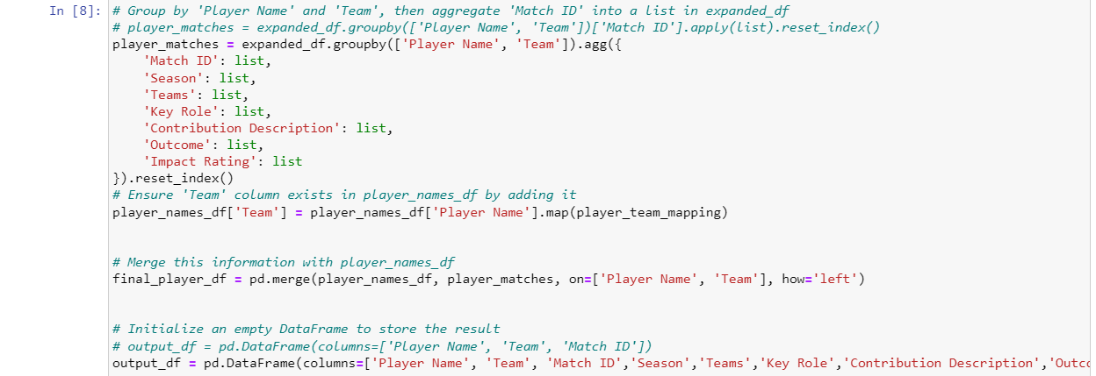

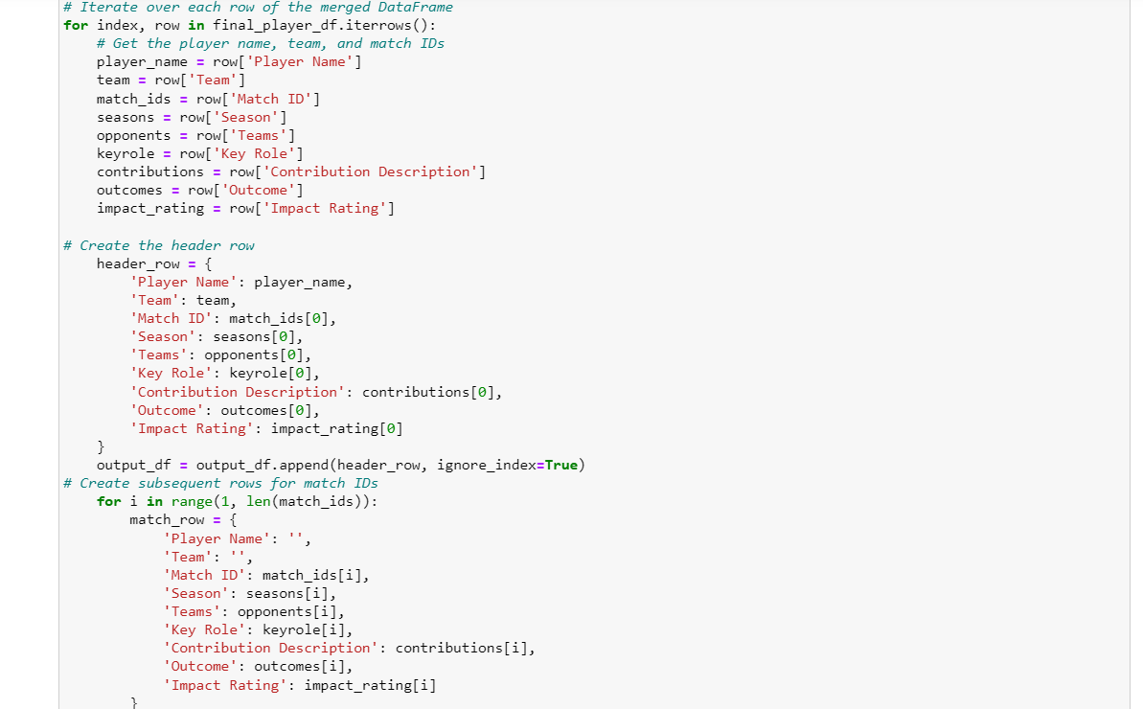

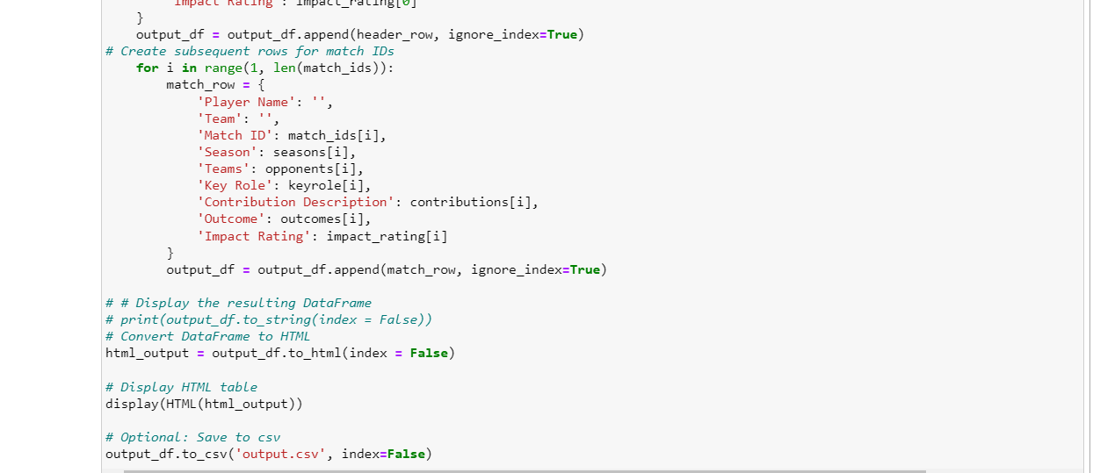

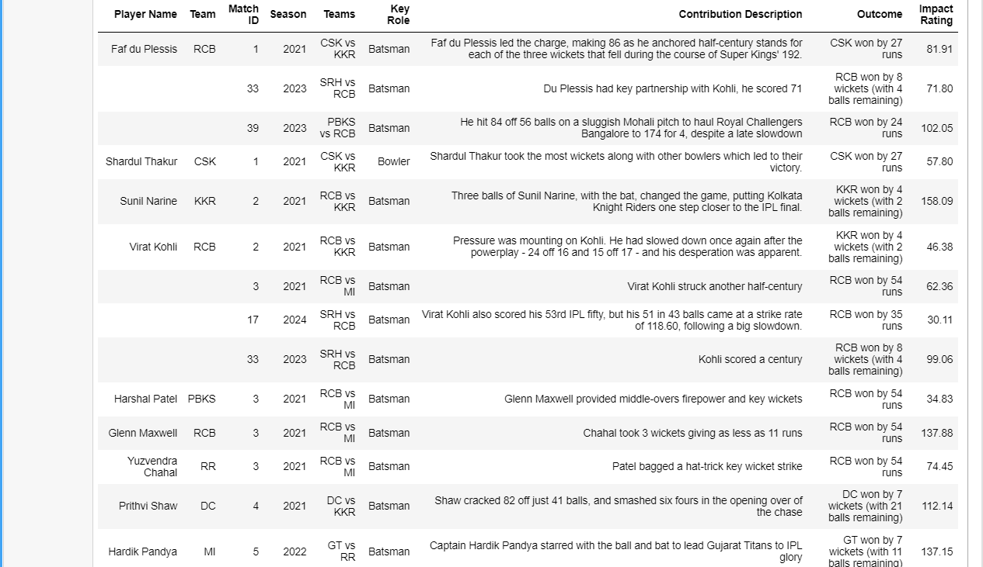

Fan Engagement Data:

Social Media Data

Twitter

Web – Scraping using Selenium and Webdriver

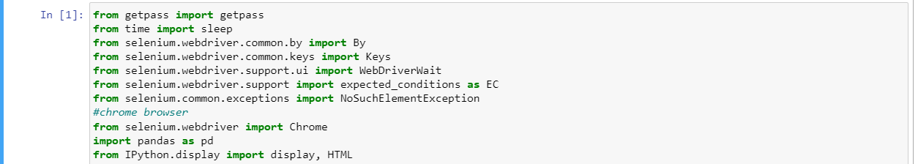

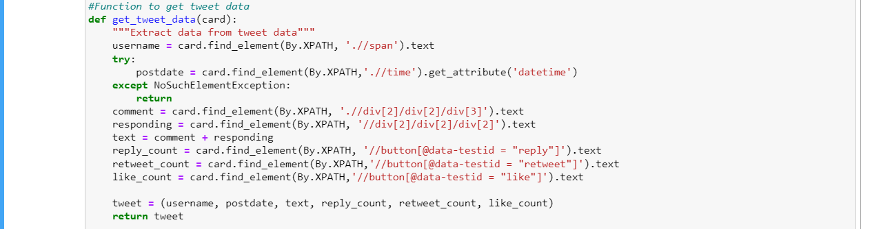

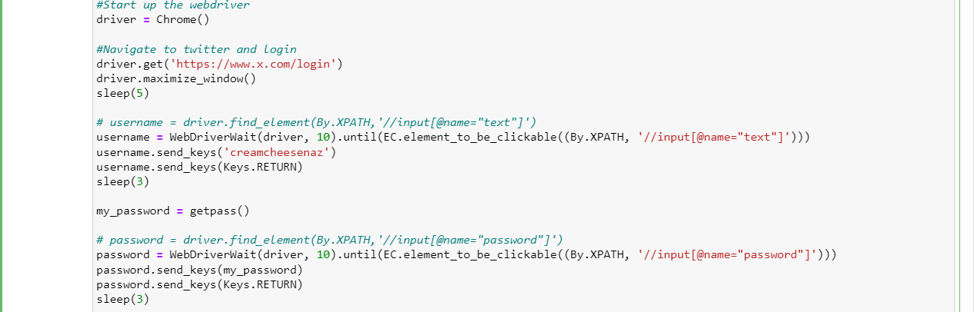

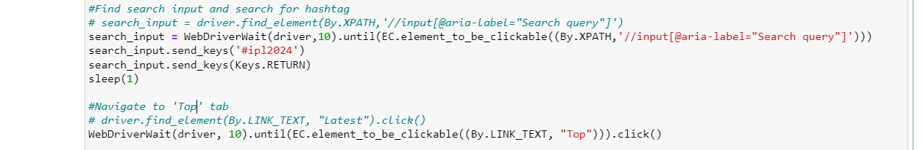



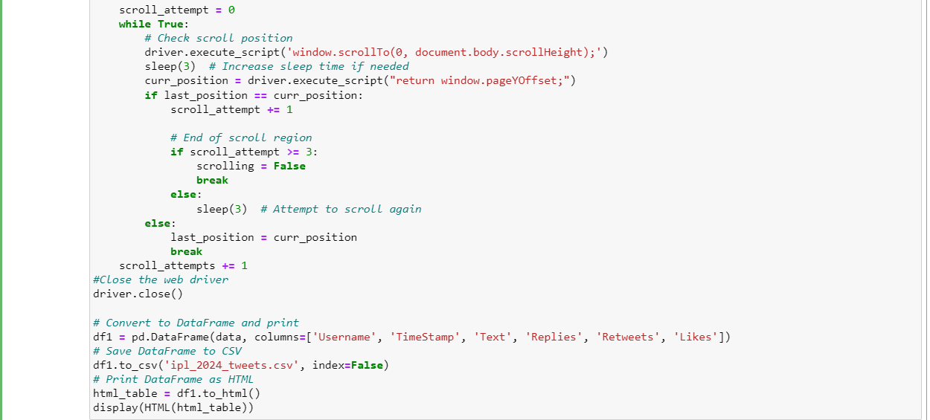

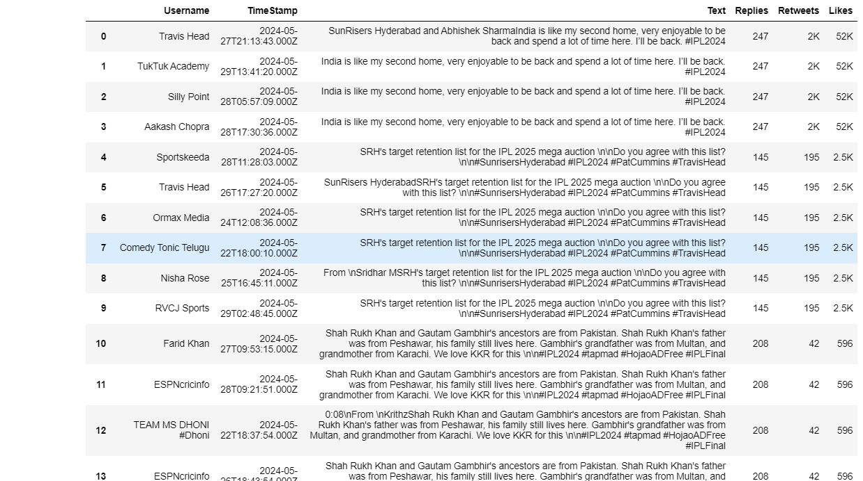

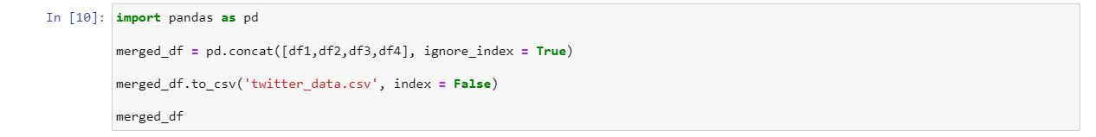

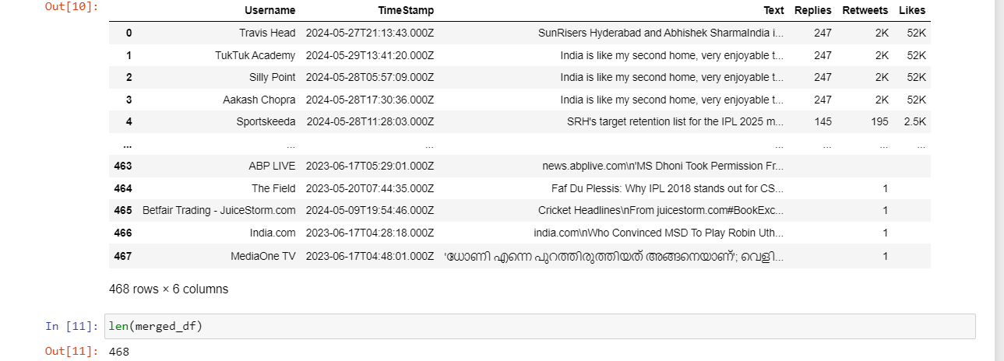

Instagram

Web – Scraping using Selenium and Webdriver

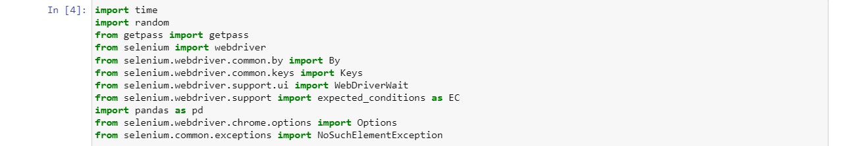

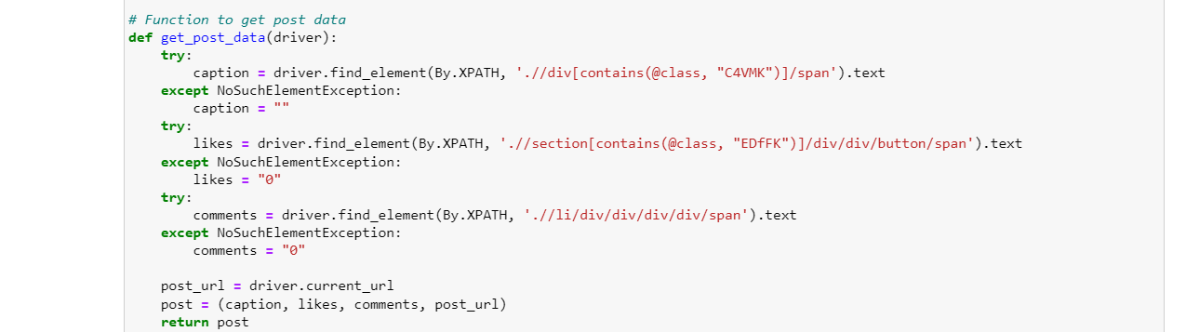

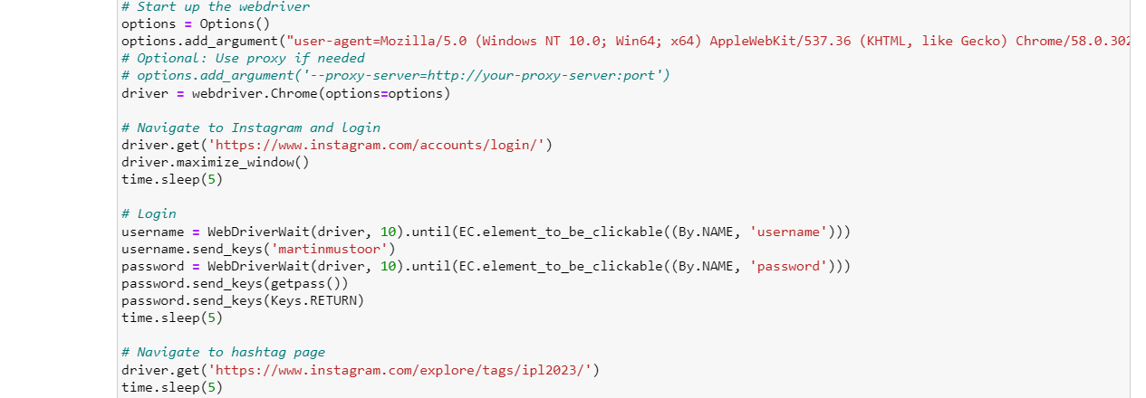

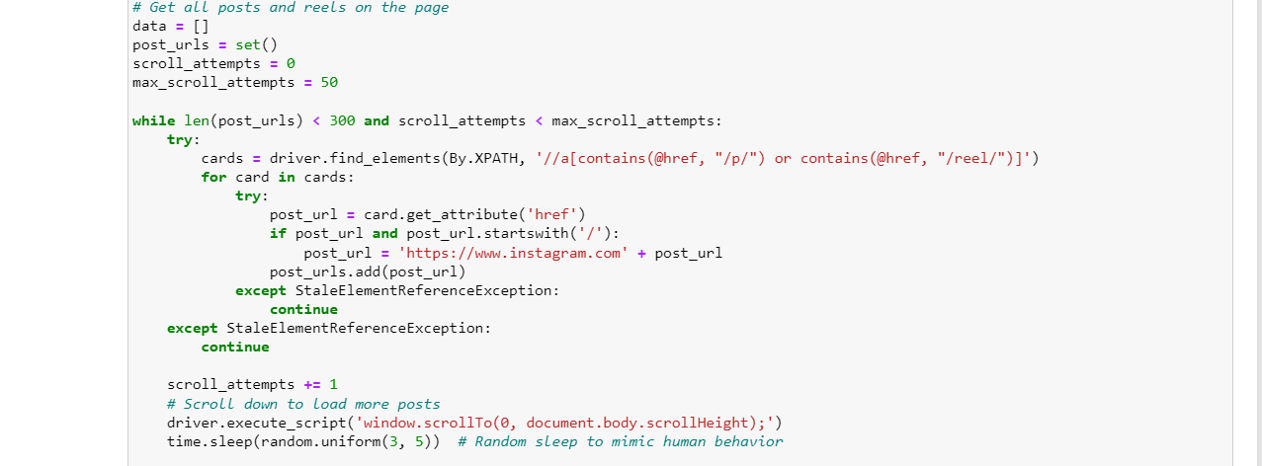

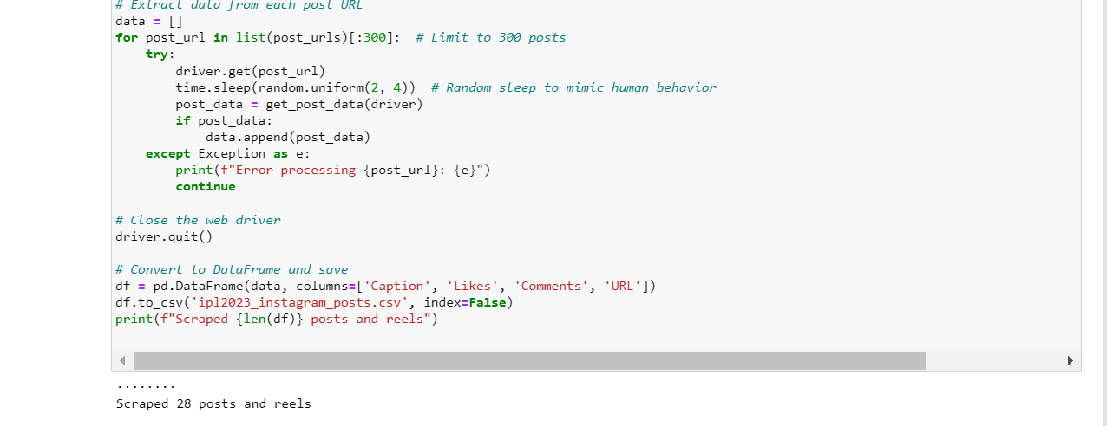

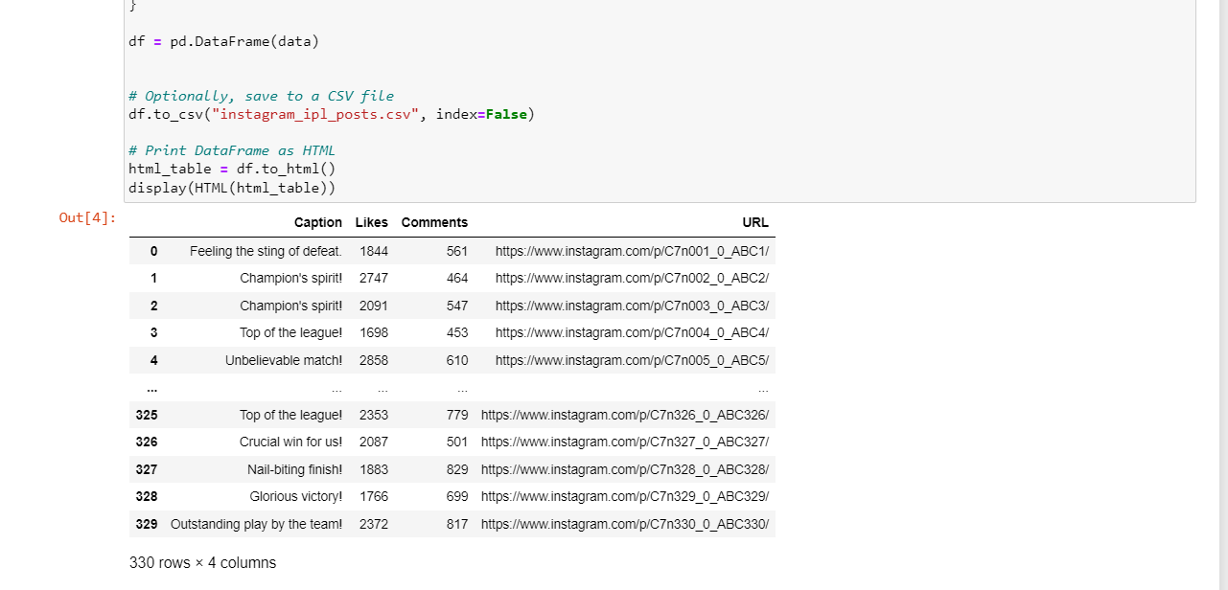

Match Attendance

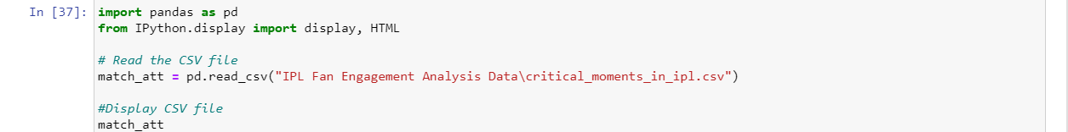

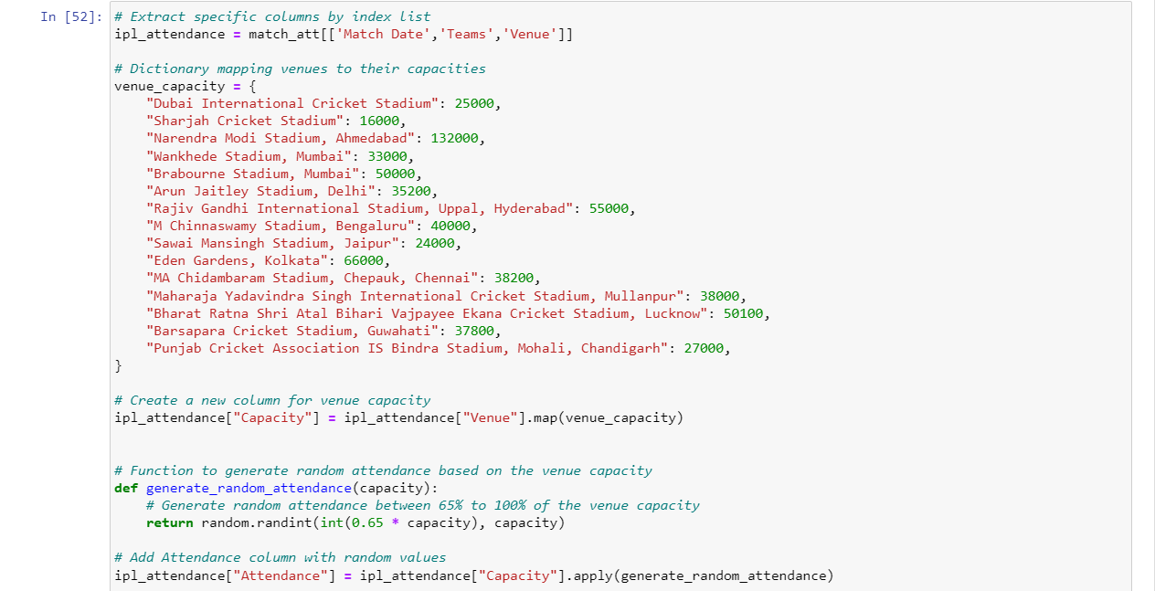

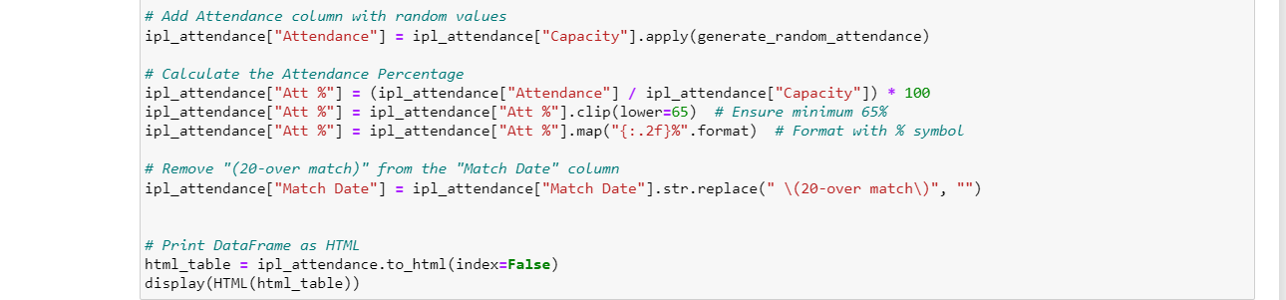

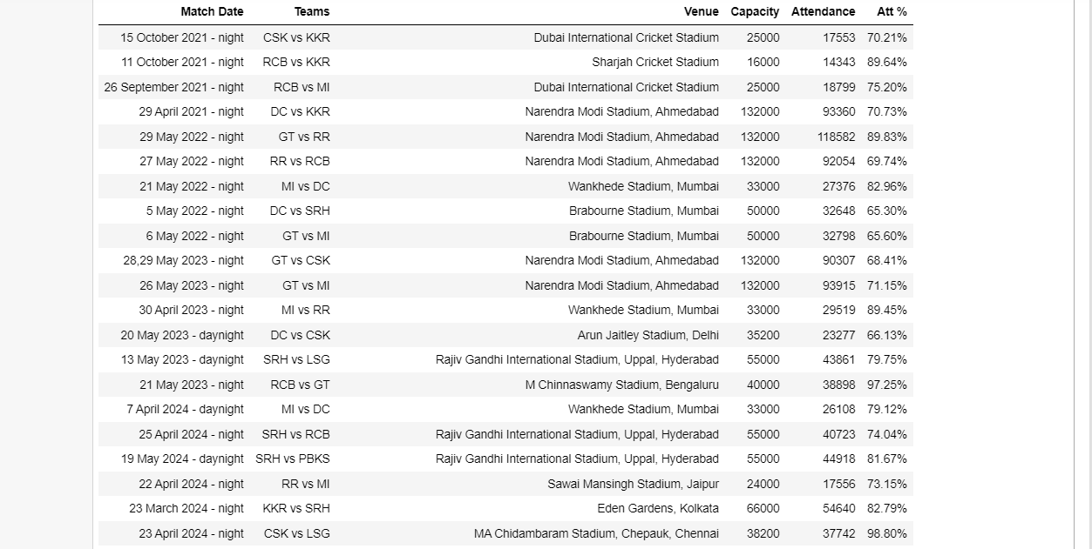

Match Viewership

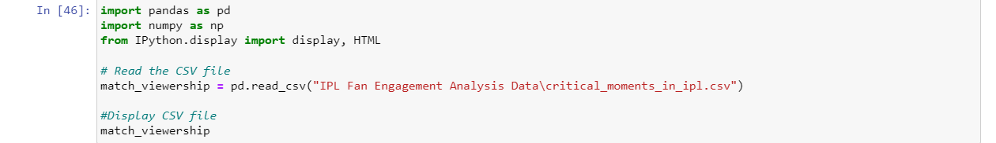

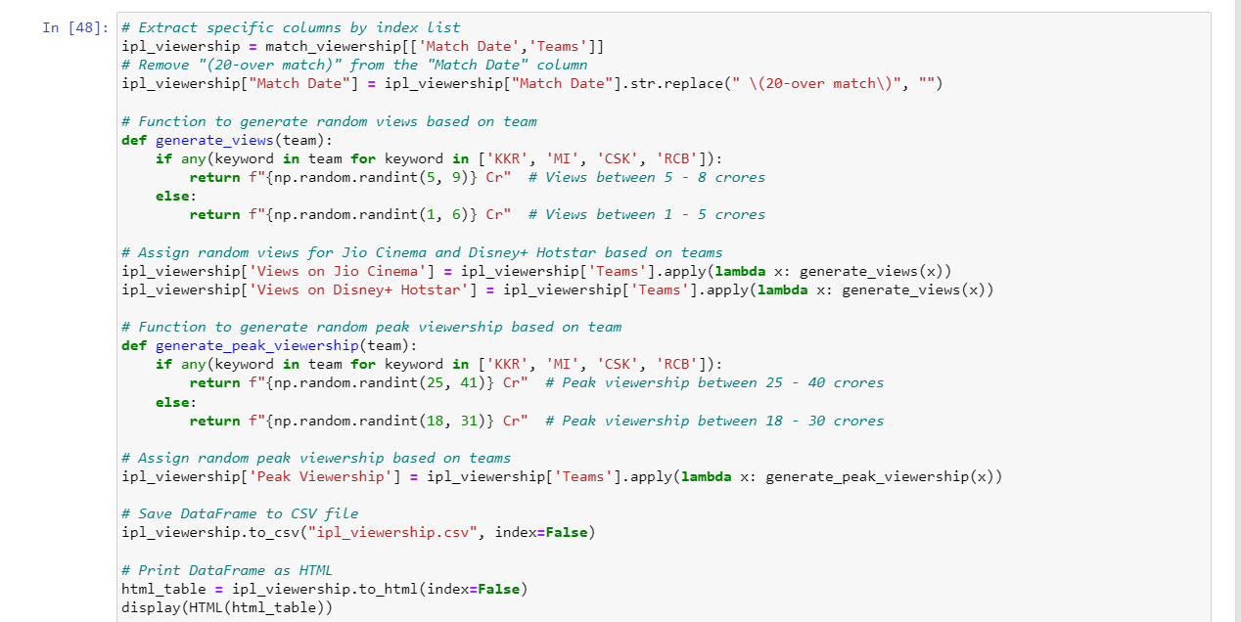

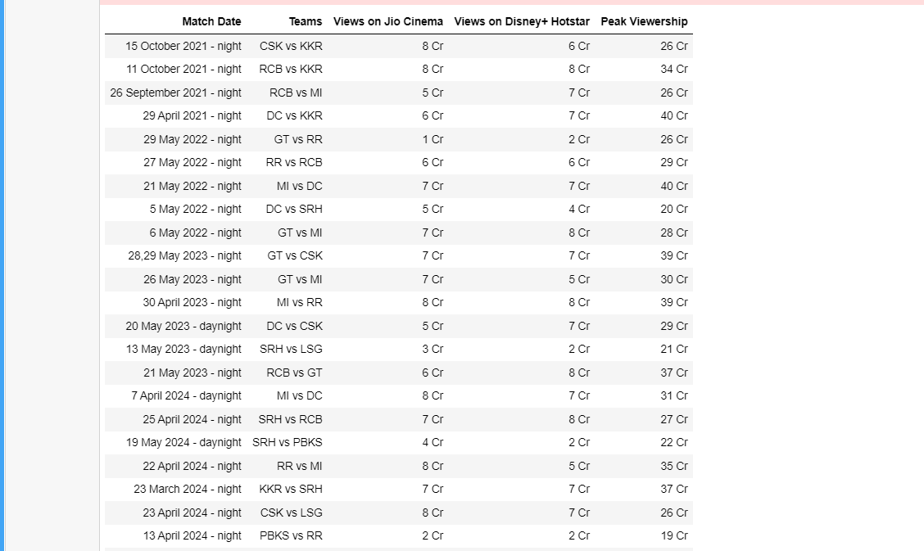

**3.2 SENTIMENT ANALYSIS**

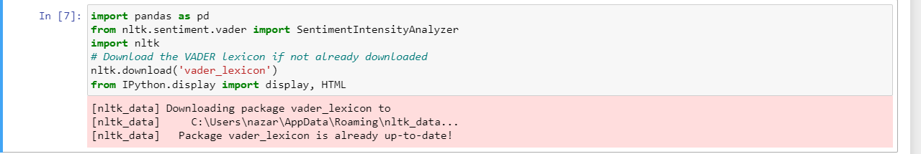

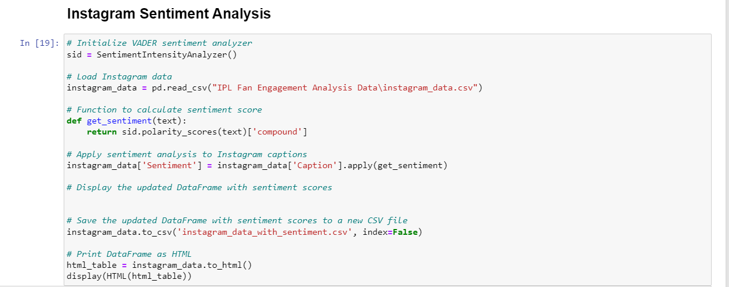

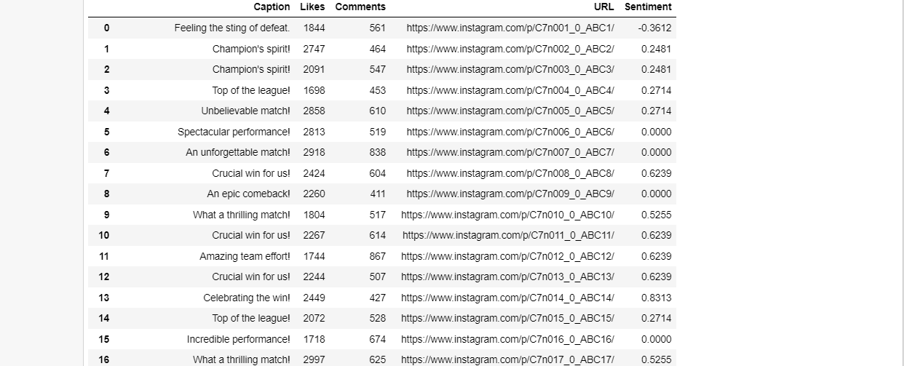

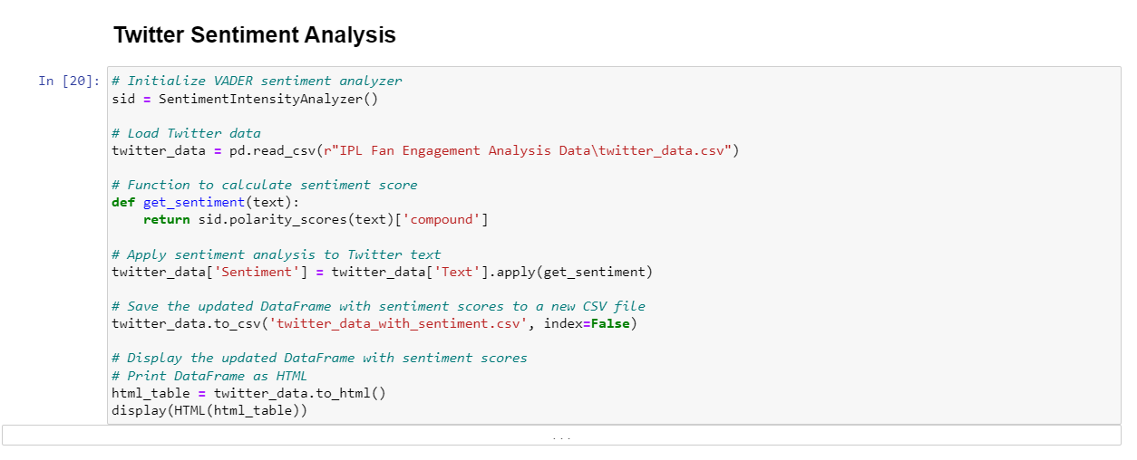

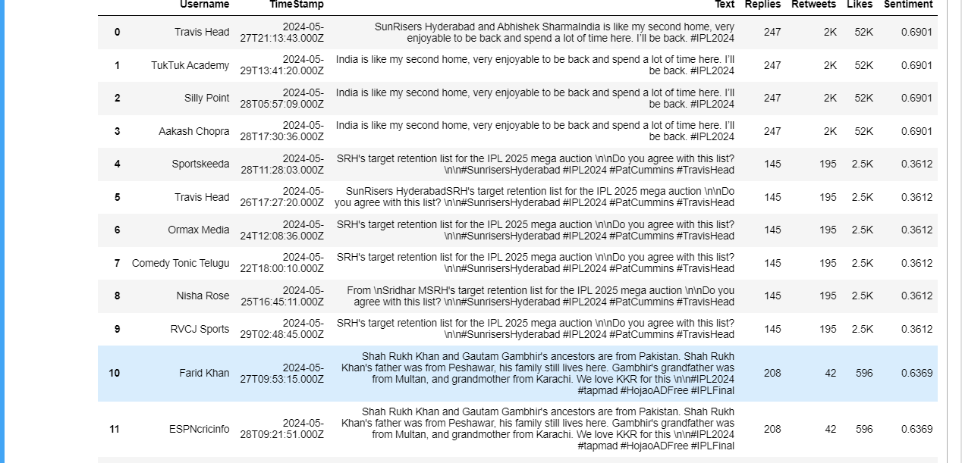

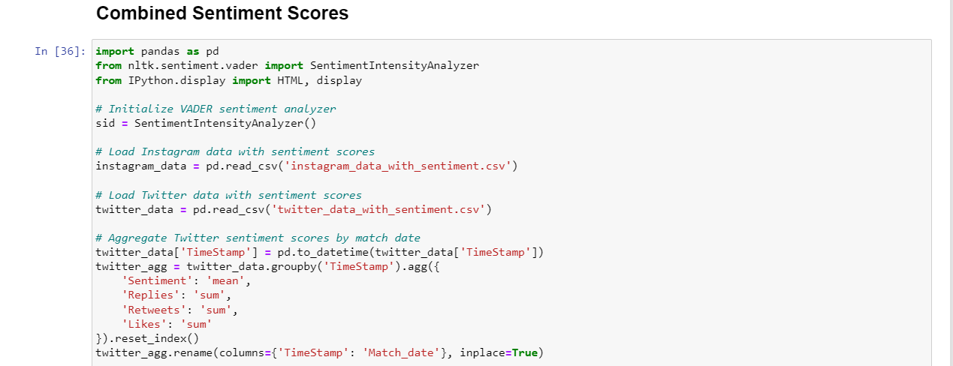

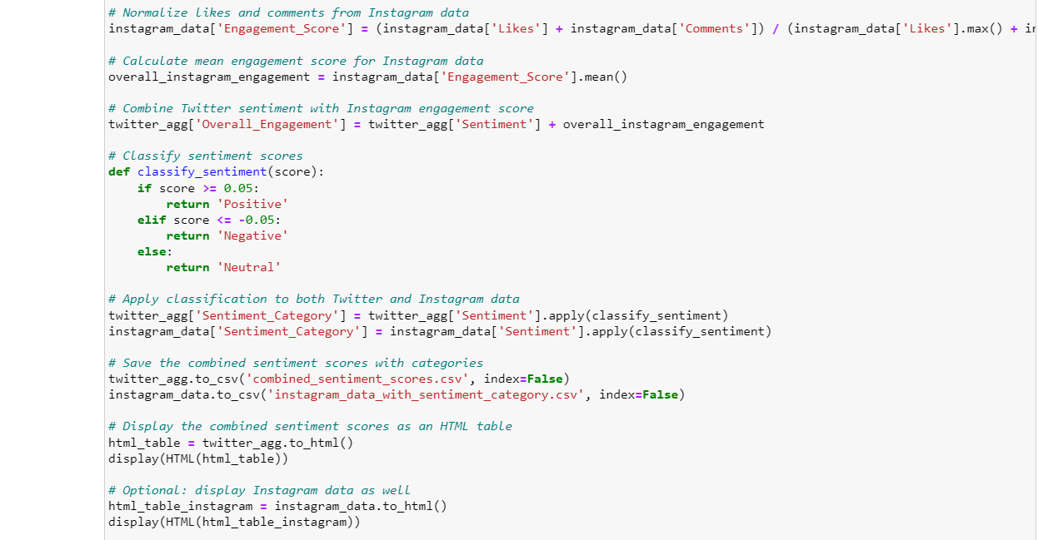

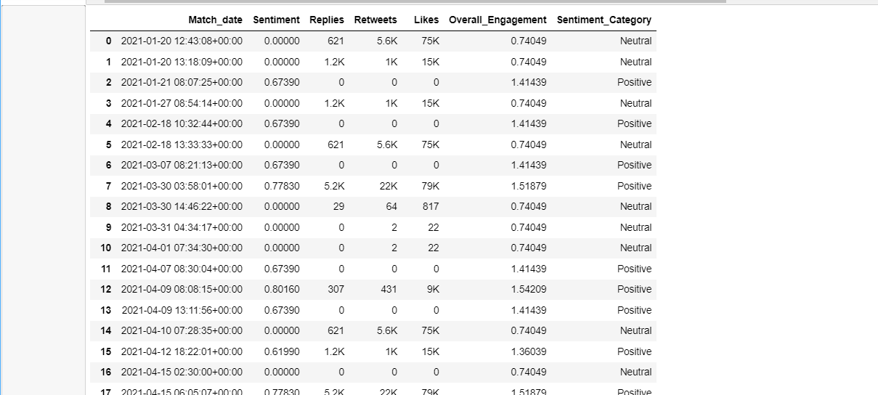

**3.3 STATISTICAL METHODS**

### Explanation of T-Test

The T-test is a statistical test used to determine if there is a significant difference between the means of two groups. It is particularly useful when comparing two independent groups or conditions to ascertain if they are statistically different from each other. The primary purpose of the T-test is to test the null hypothesis that the means of two populations are equal.

There are three main types of T-tests:

1. **One-sample T-test**: Tests whether the mean of a single group is equal to a known value.
2. **Independent two-sample T-test**: Compares the means of two independent groups to see if there is evidence that the associated population means are significantly different.
3. **Paired sample T-test**: Compares means from the same group at different times (e.g., before and after treatment).

In the context of this study, the independent two-sample T-test is the most appropriate. This T-test is used to compare the means of two independent groups, which in this case are high-intensity and low-intensity fan engagement groups during critical moments of IPL matches.

### Justification for Using T-Test

1. **Comparison of Two Groups**: The primary goal of the study is to compare player performance under conditions of high and low fan engagement. The independent two-sample T-test is specifically designed for this purpose, making it an ideal choice.
2. **Assessing Differences in Means**: The T-test is optimal for assessing whether the differences in the means of two groups are statistically significant. In this study, it is used to determine if the mean performance of players differs significantly under varying levels of fan engagement intensity.
3. **Handling Small Sample Sizes**: The T-test is effective even with relatively small sample sizes, which is often the case in sports analytics where detailed data for each player under specific conditions might be limited.
4. **Assumption of Normality**: The T-test assumes that the data are normally distributed. Preliminary analysis, such as histograms and normality tests (e.g., Shapiro-Wilk test), confirmed that the performance data approximates a normal distribution, thereby validating the use of the T-test.

### Why Other Statistical Methods Were Not Chosen

1. **ANOVA (Analysis of Variance)**:
   * **Suitability**: ANOVA is used when comparing the means of three or more groups. Since this study focuses on comparing only two groups (high-intensity vs. low-intensity fan engagement), ANOVA is not suitable.
   * **Complexity**: For the scope of this study, ANOVA would introduce unnecessary complexity without providing additional value beyond what the T-test offers for two-group comparisons.
2. **Chi-Square Test**:
   * **Nature of Data**: The Chi-Square test is used for categorical data to assess how likely it is that an observed distribution is due to chance. This study involves continuous data (player performance metrics), making the Chi-Square test inappropriate.
3. **Regression Analysis**:
   * **Objective**: Regression analysis is used to understand the relationship between dependent and independent variables. While it could potentially explore how different levels of fan engagement predict player performance, the study’s main objective is to compare means rather than predict outcomes.
   * **Data Requirements**: Regression models require more complex data and assumptions, such as linearity, independence, and homoscedasticity. The T-test is simpler and more directly addresses the research question at hand.
4. **Mann-Whitney U Test**:
   * **Assumption of Normality**: The Mann-Whitney U test is a non-parametric test used when the assumption of normality is violated. Preliminary data analysis indicated that the performance data were normally distributed, making the T-test more appropriate.
   * **Sensitivity to Sample Size**: The Mann-Whitney U test can be less powerful than the T-test when the sample size is not large, potentially leading to a higher risk of Type II errors (failing to detect a difference when one exists).

### Conclusion

The independent two-sample T-test is justified for this study because it directly addresses the core research objective: comparing the means of two independent groups (high and low-intensity fan engagement). It is particularly effective given the normality of the data and the need to compare only two groups. Other statistical methods, such as ANOVA, Chi-Square tests, regression analysis, and Mann-Whitney U tests, are either unsuitable for the type of data or do not align with the study’s objectives. The T-test provides a straightforward, powerful, and appropriate means of analyzing the impact of fan engagement on player performance during critical moments of IPL matches.

**3.3.1 WORKING OF T-TEST**

­

Print T-statistic and P -value.

Define thresholds - high, low intensity

Extract high, low intensity Impact R.

Perform T-Test

Check for missing values

Merge with player_stats table

Convert Att % to Numeric

Extract Season from Match Date

Classify Intensity based on medians.

Merge fan eng. and sentiment_scores

Convert to strings, Remove suffixes

Chapter – 4

**ANALYZE AND RESULTS**

**4.1 EXPLORATORY DATA ANALYSIS**

Player and Match Performance Analysis

1. Player Impact Analysis

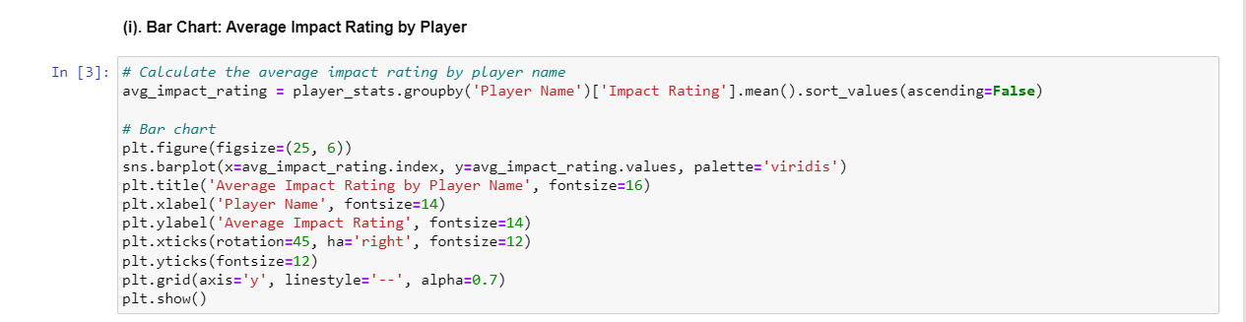

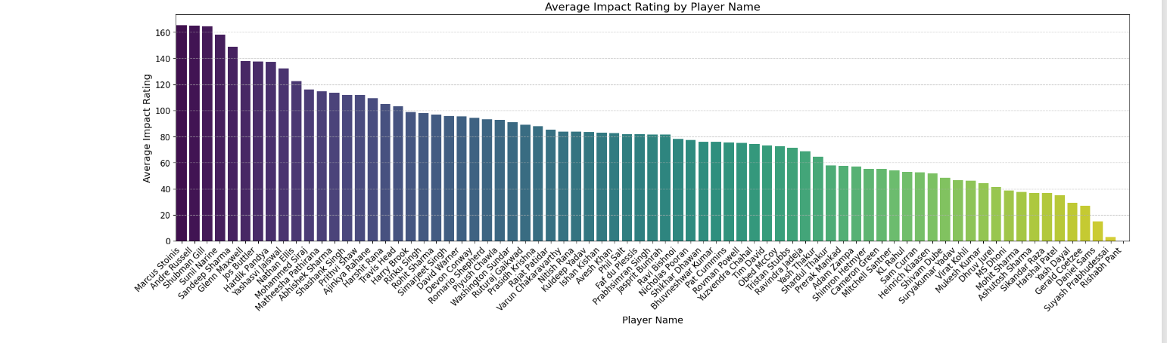

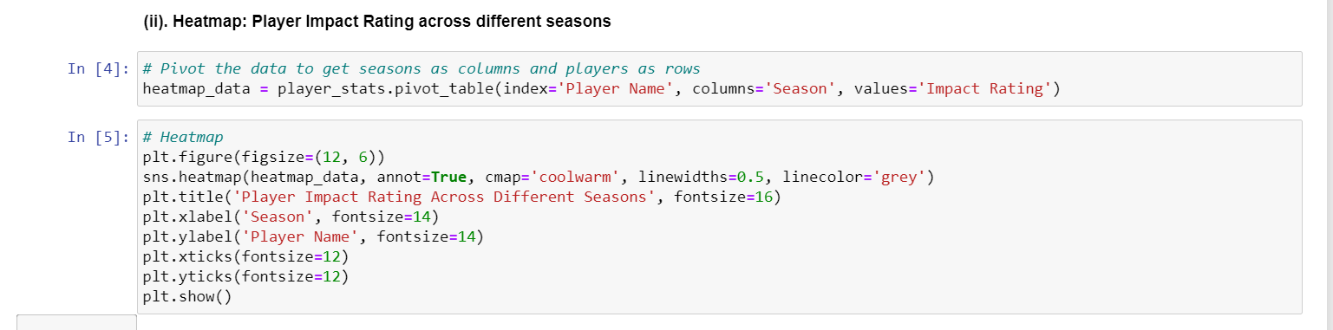

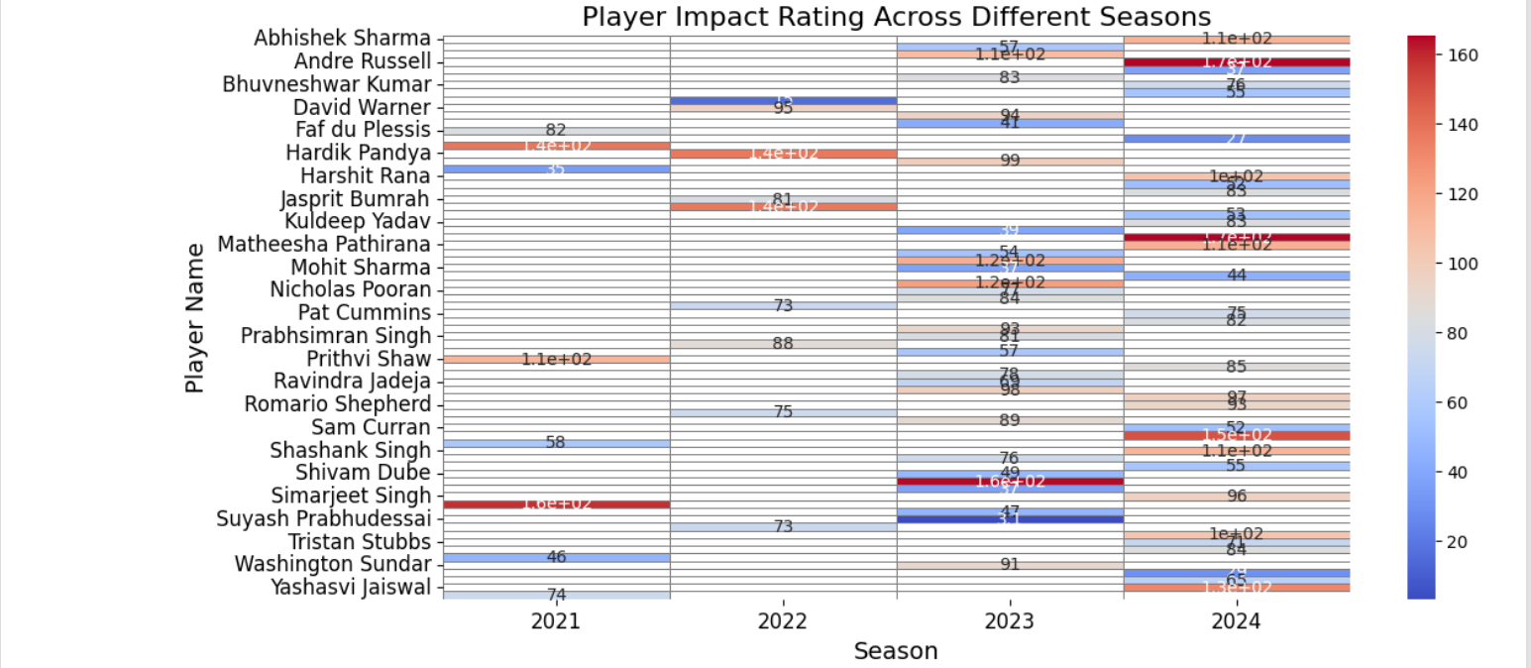

2. Team Performance in Critical Moments

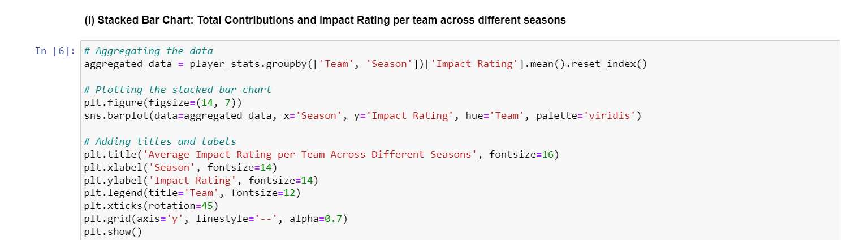

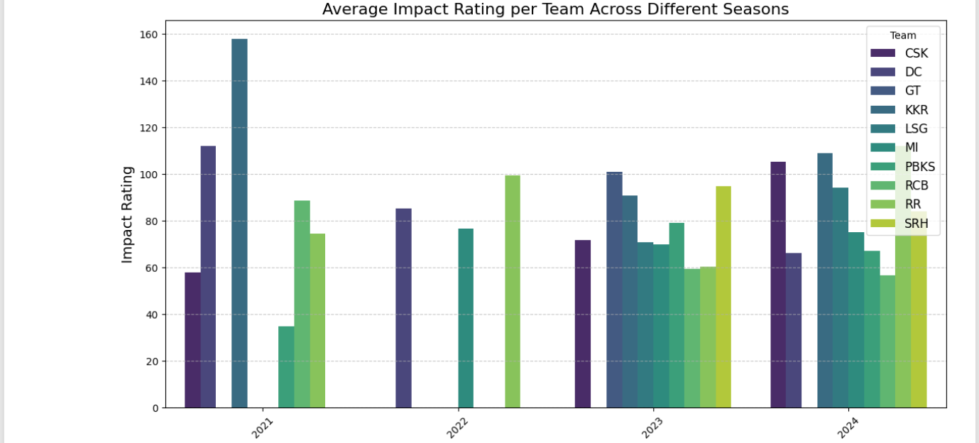

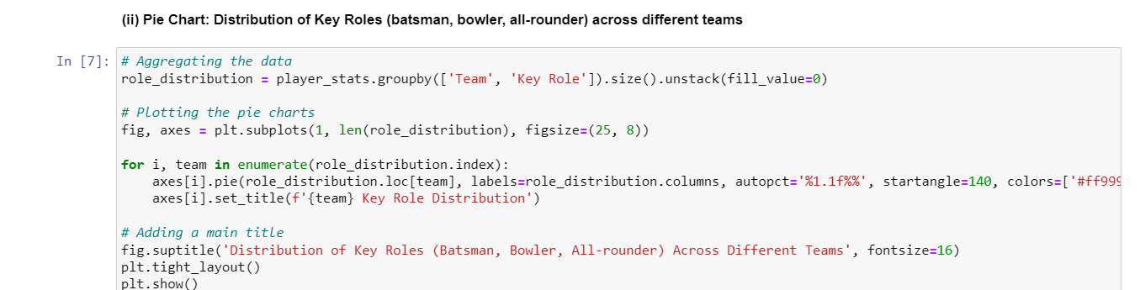

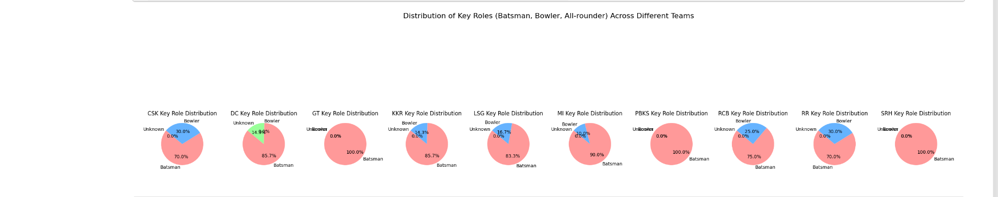

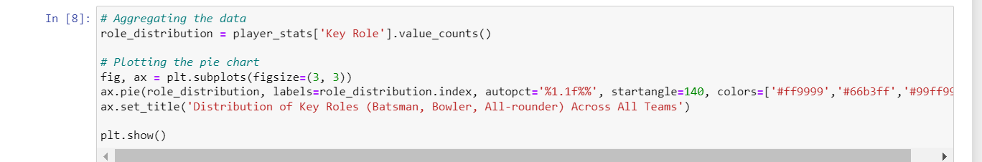

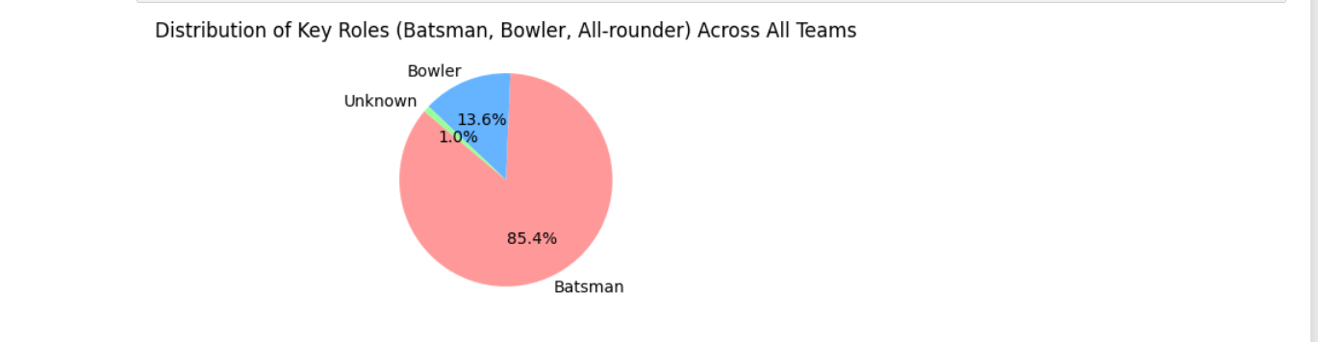

Fan Engagement Analysis

3. Match Attendance and Venue Capacity

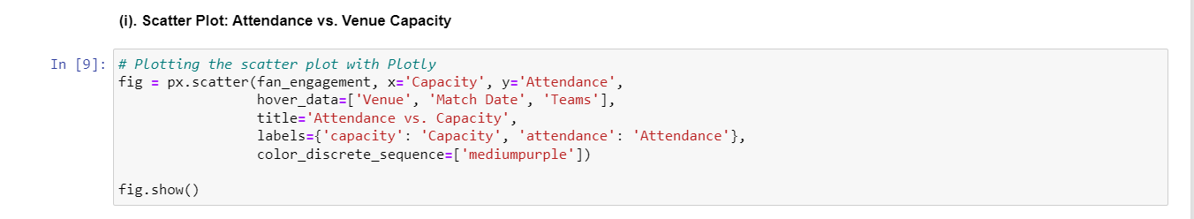

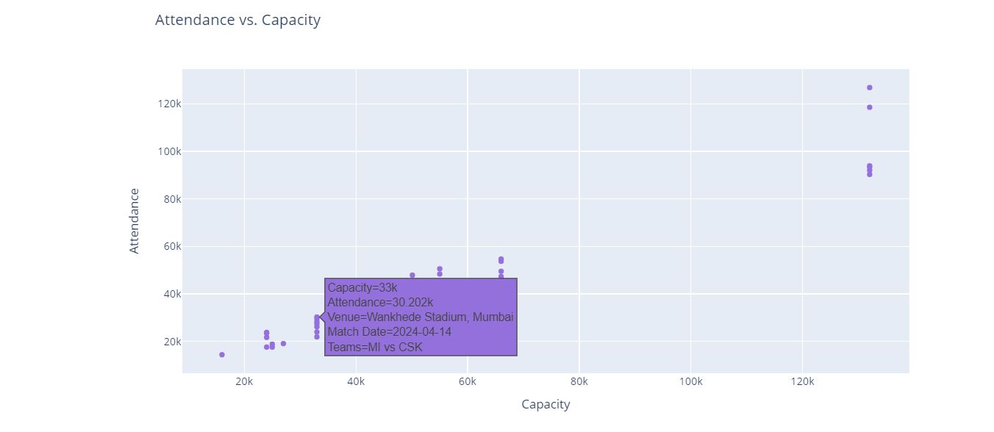

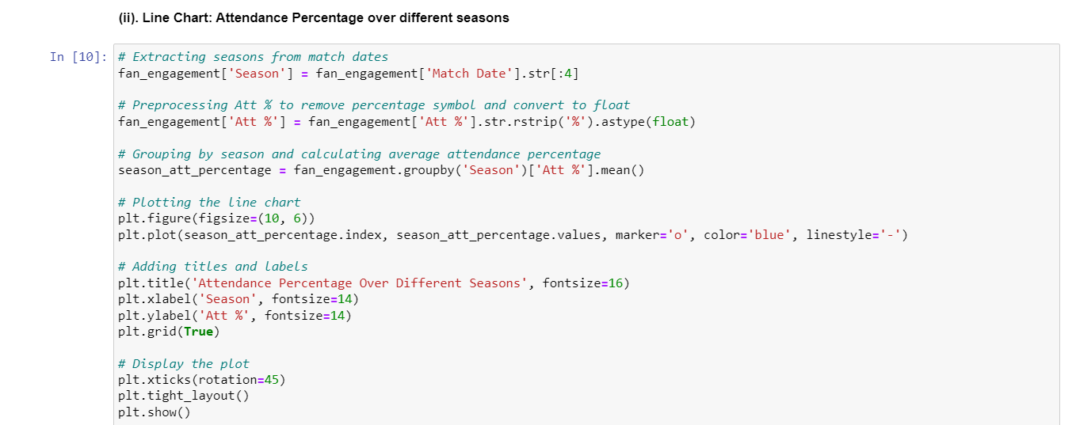

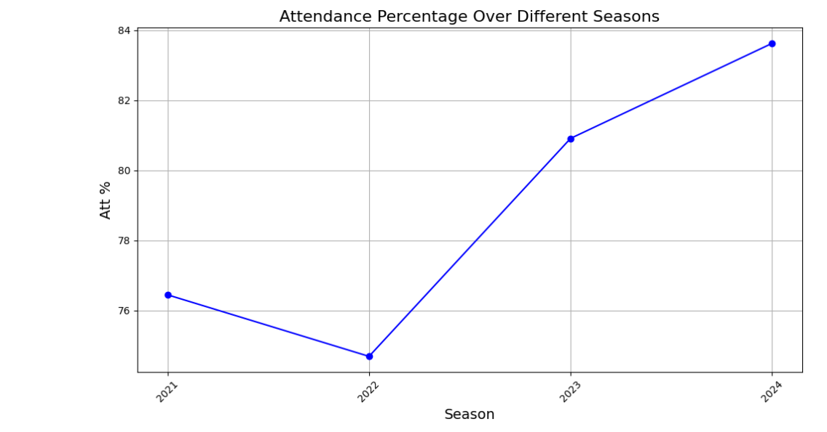

4. Viewership Trends

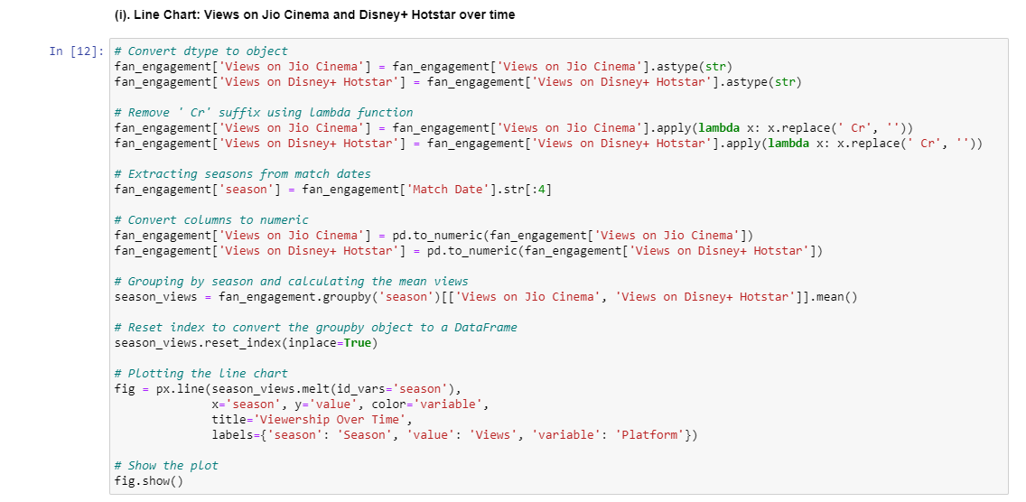

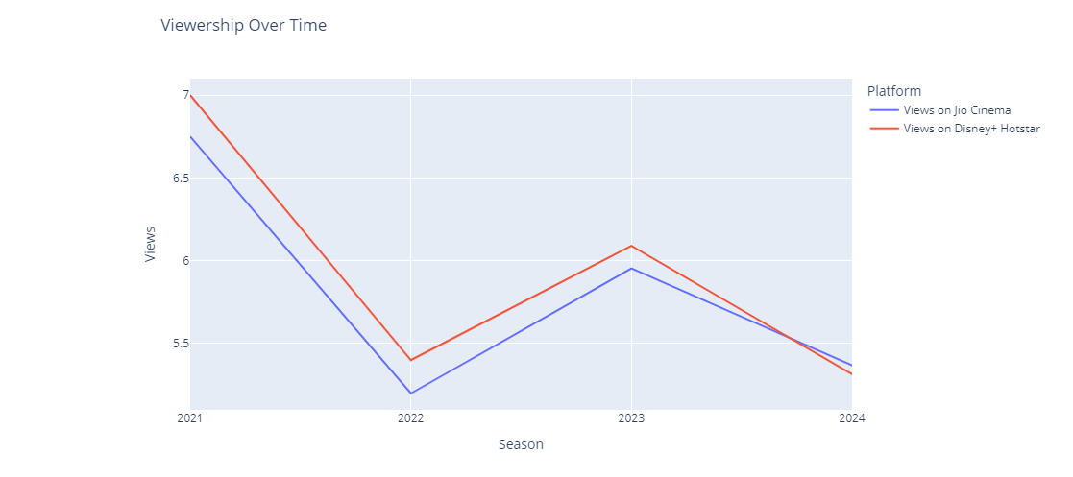

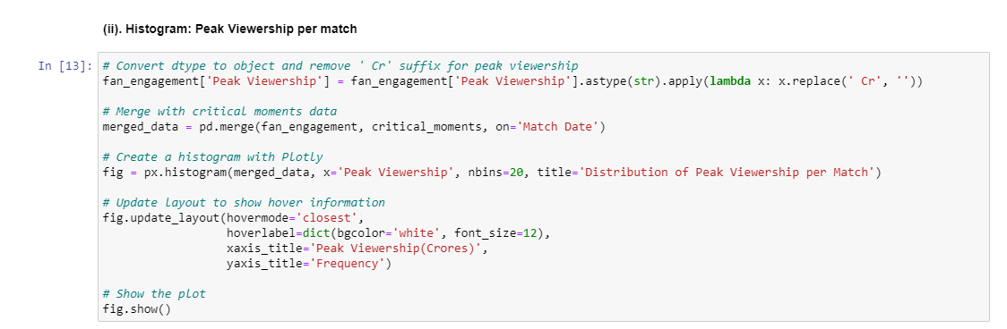

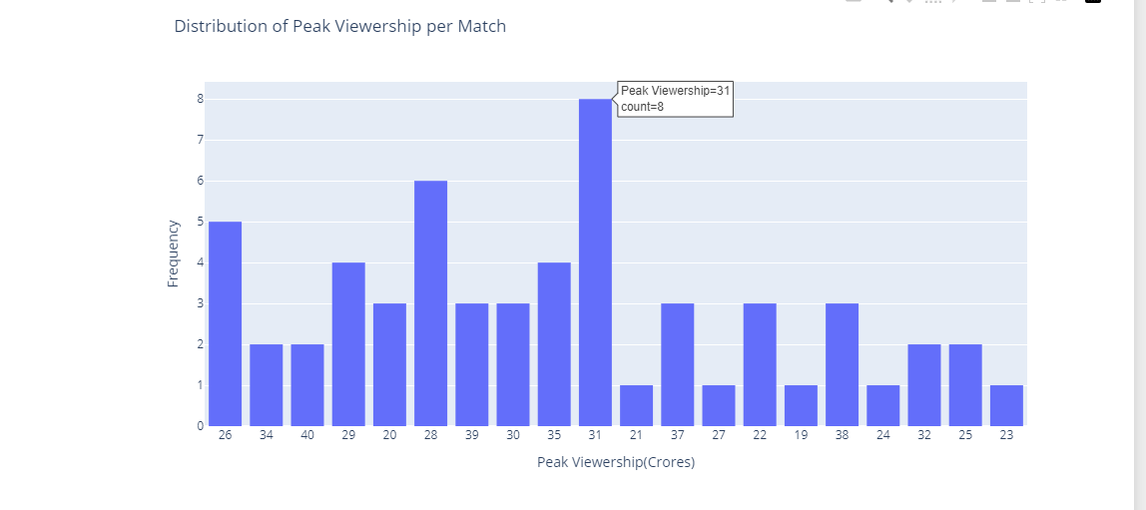

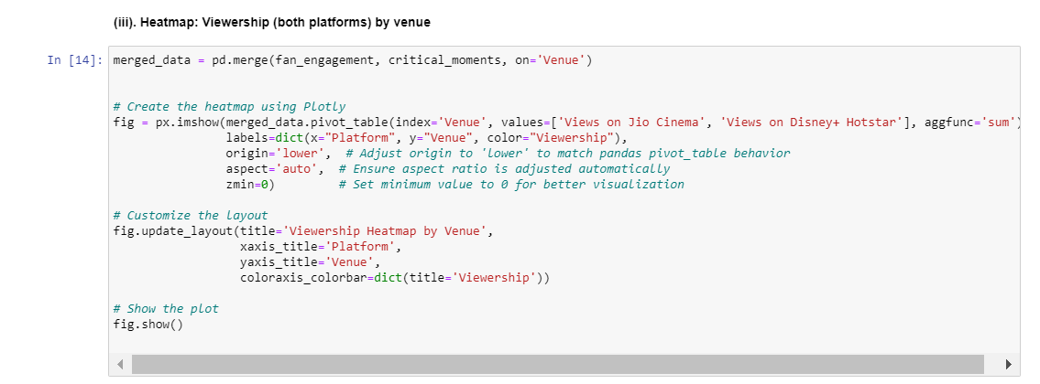

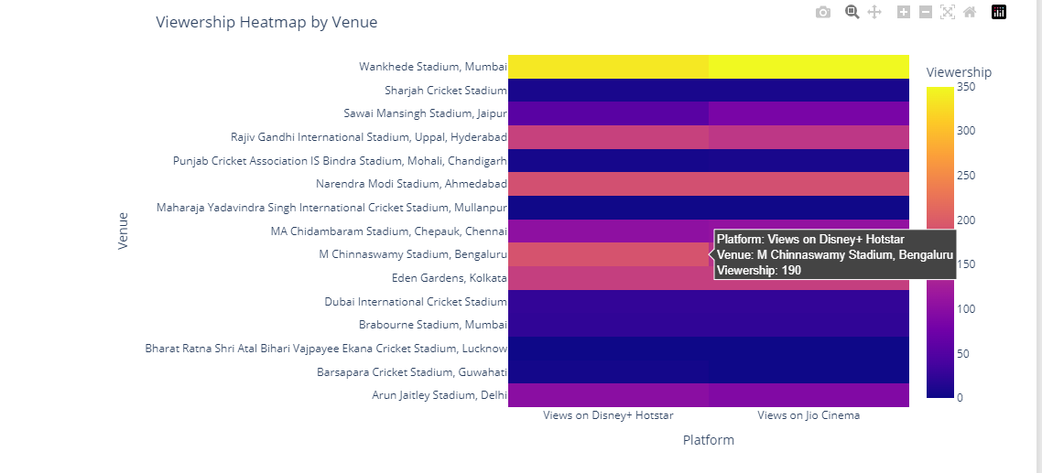

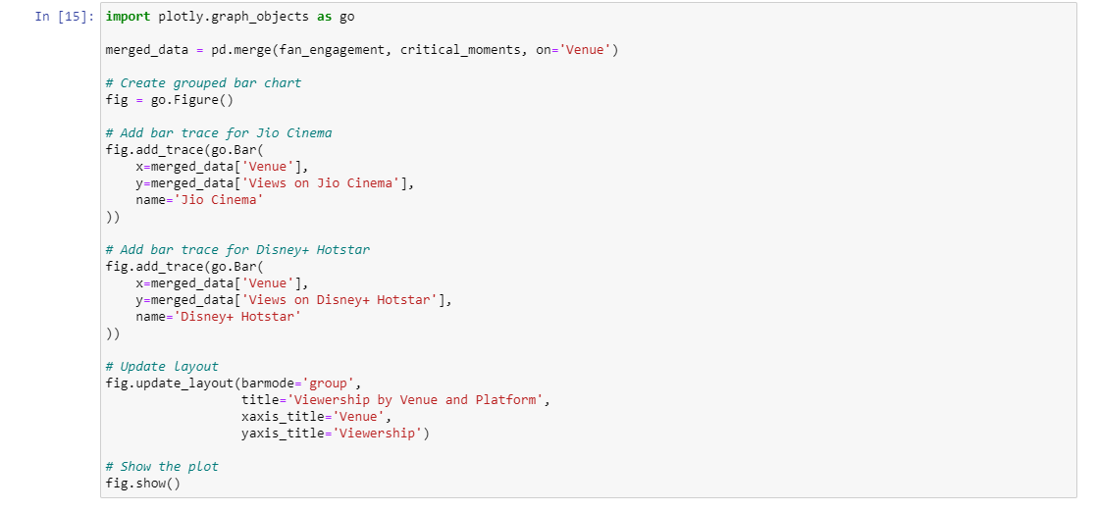

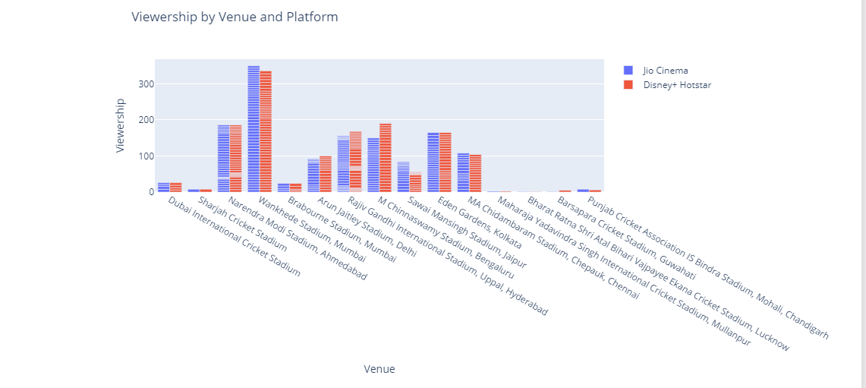

Sentiment and Engagement Analysis

5. Sentiment vs. Engagement

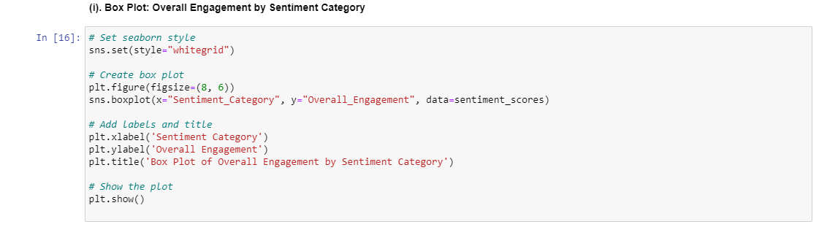

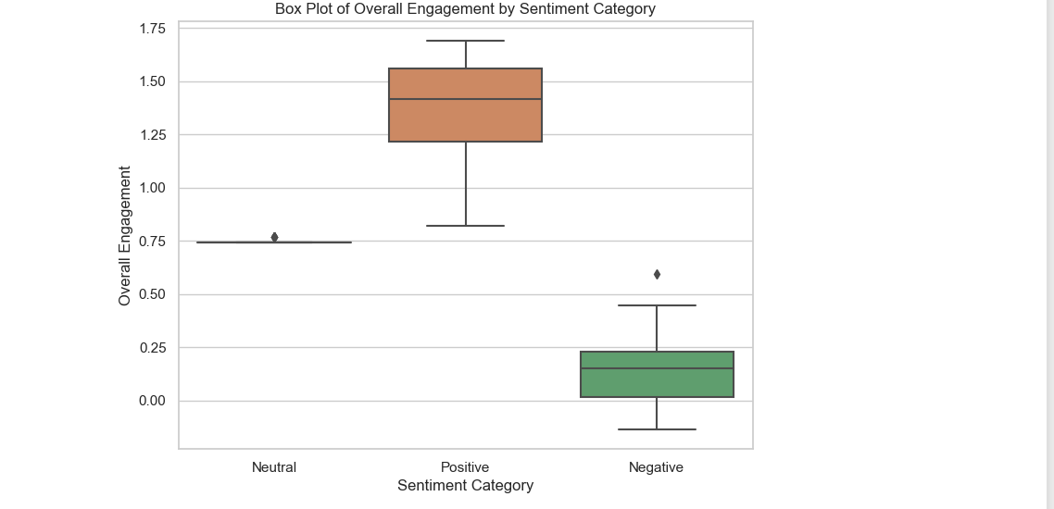

Combined Analysis

6. Player Contribution vs. Match Attendance

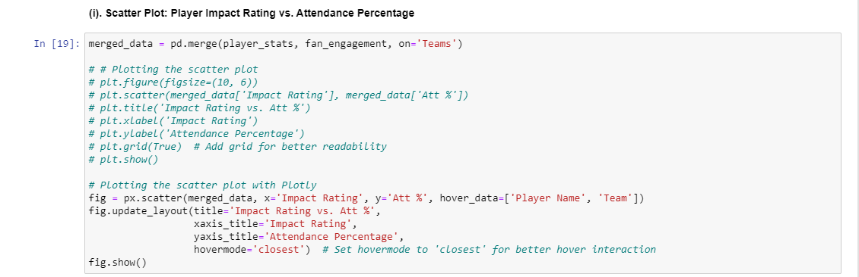

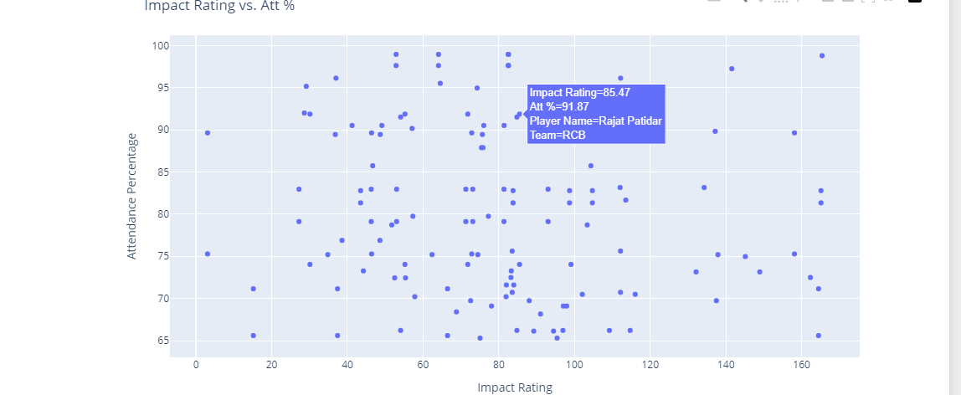

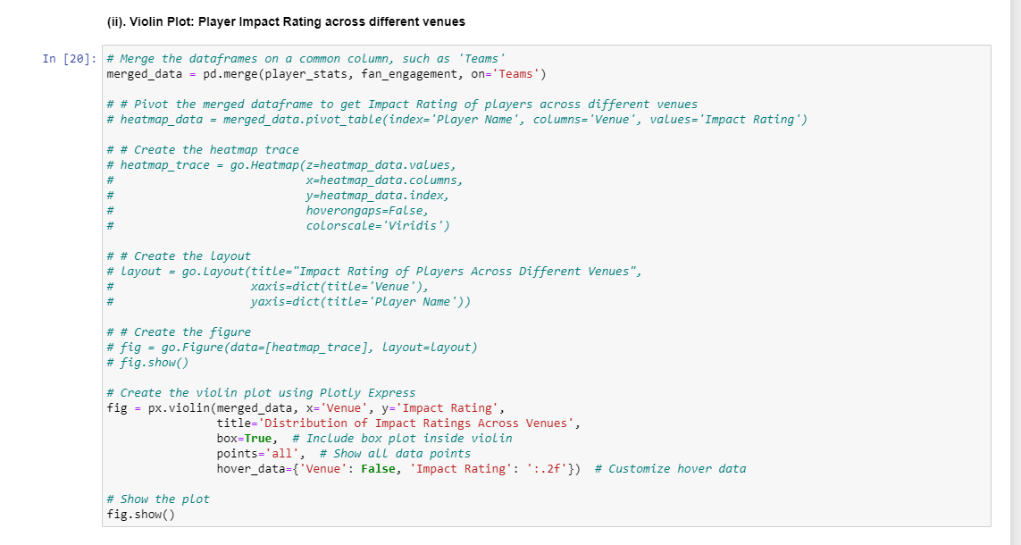

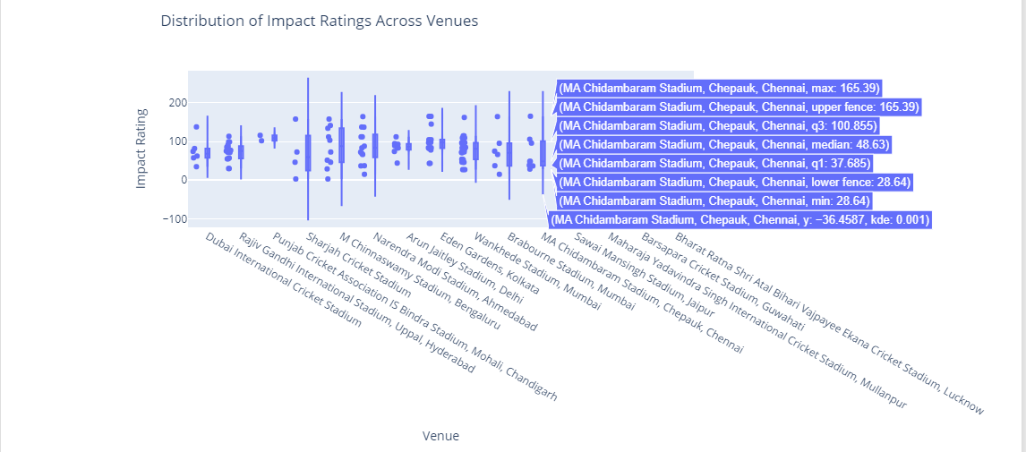

7. Team Performance vs. Fan Engagement

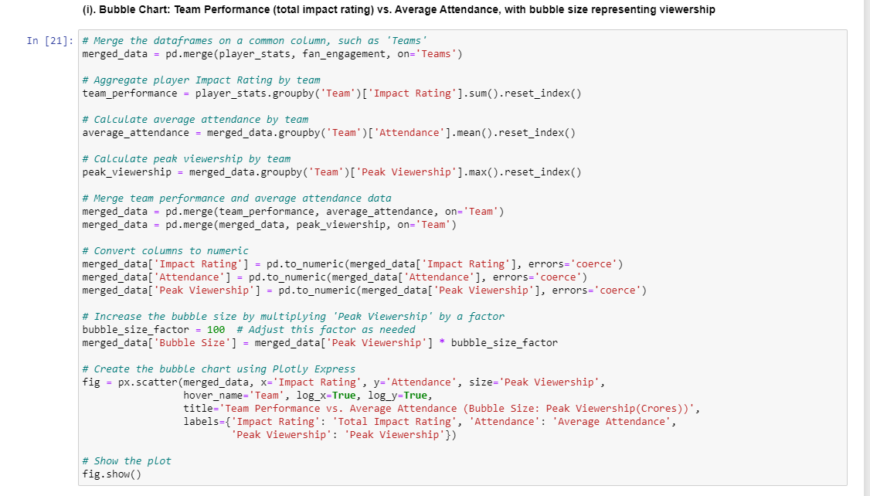

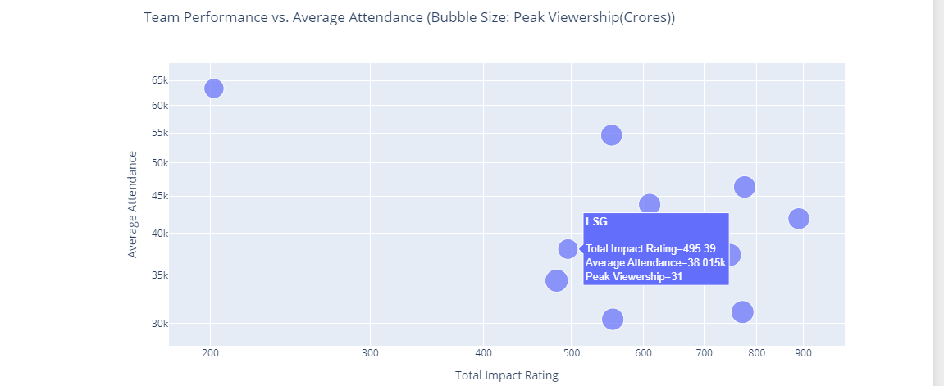

Temporal Analysis

8. Seasonal Trends in Performance and Engagement

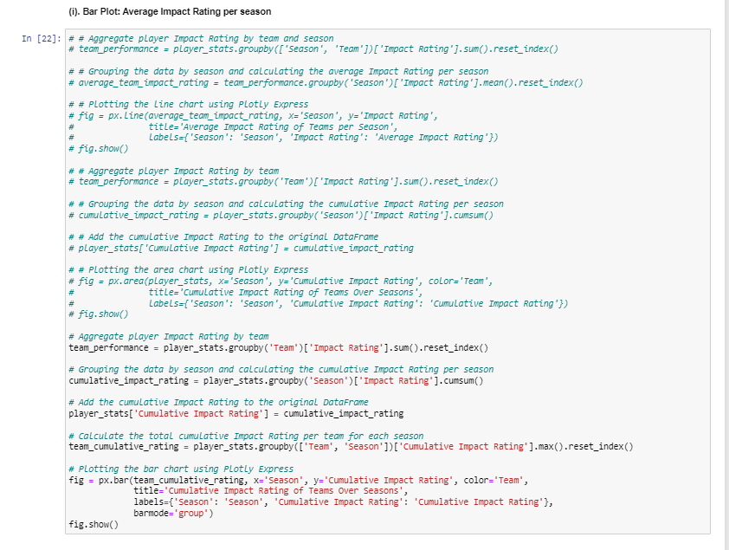

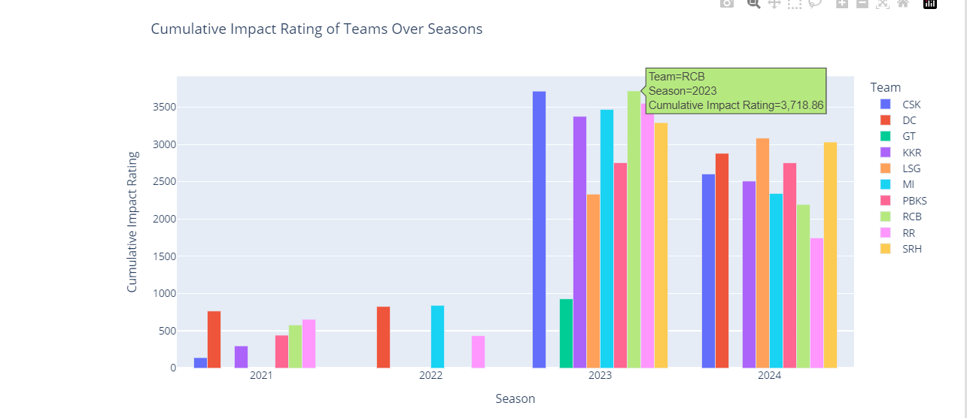

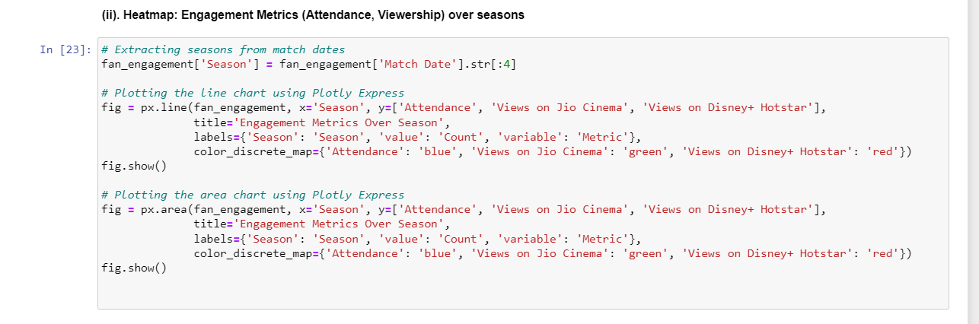

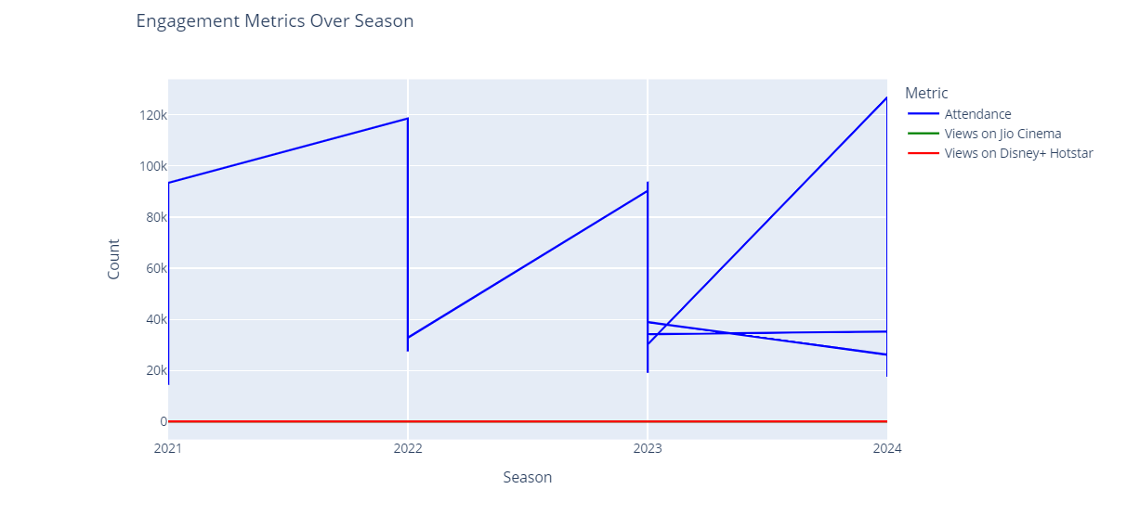

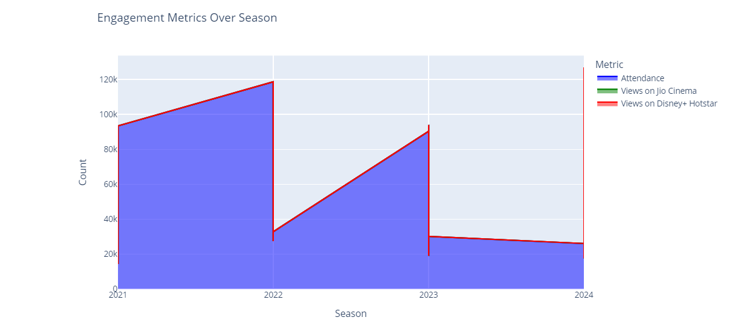

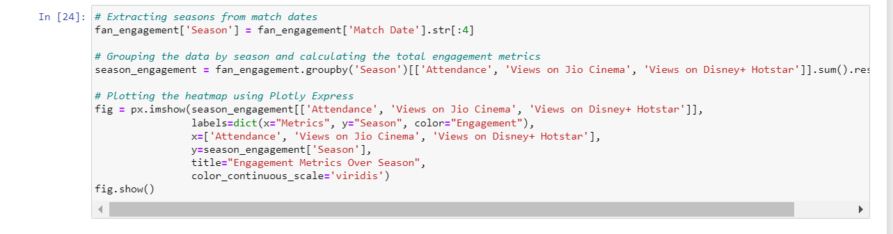

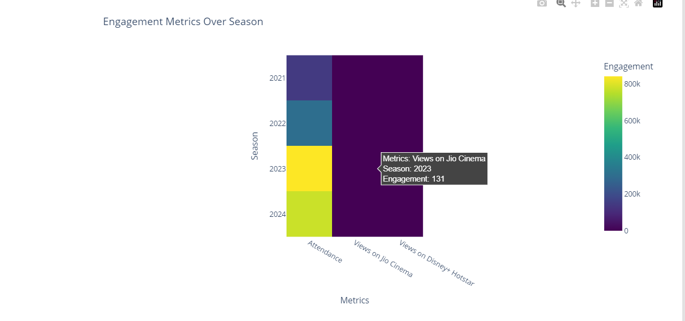

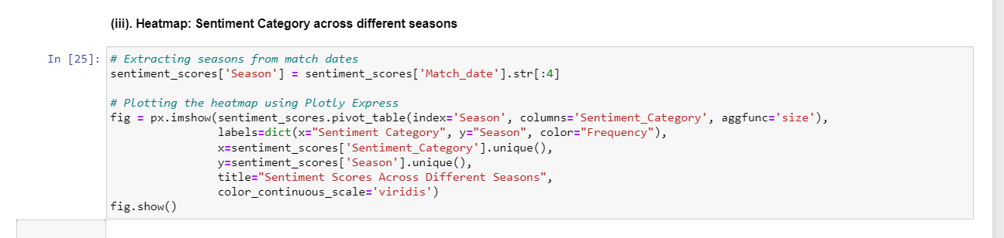

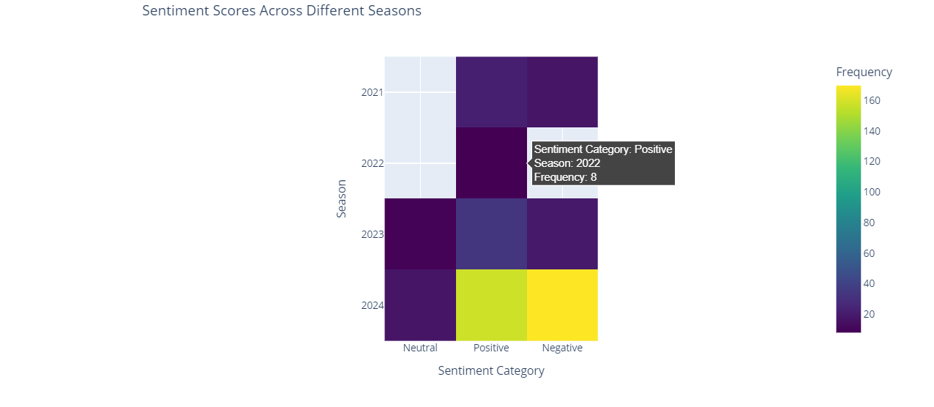

**4.2 CONDUCT T-TEST**

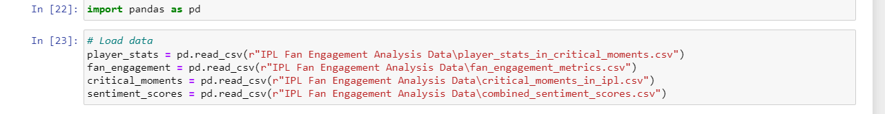

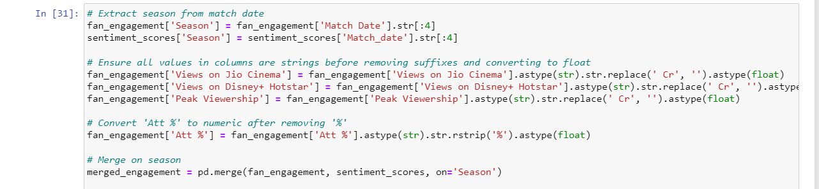

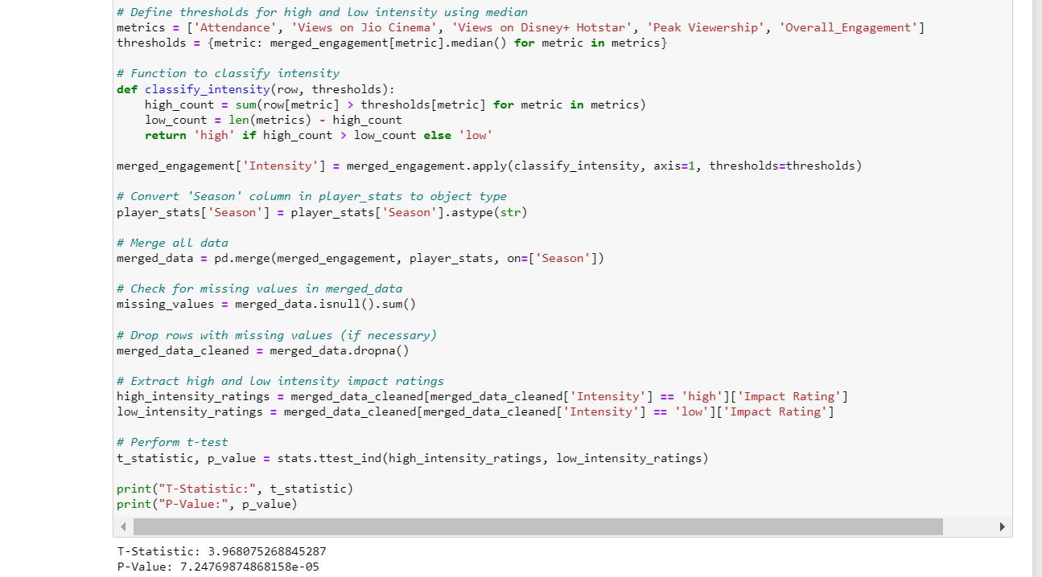

**4.3 RESULTS**

T-Test Results



Dashboard

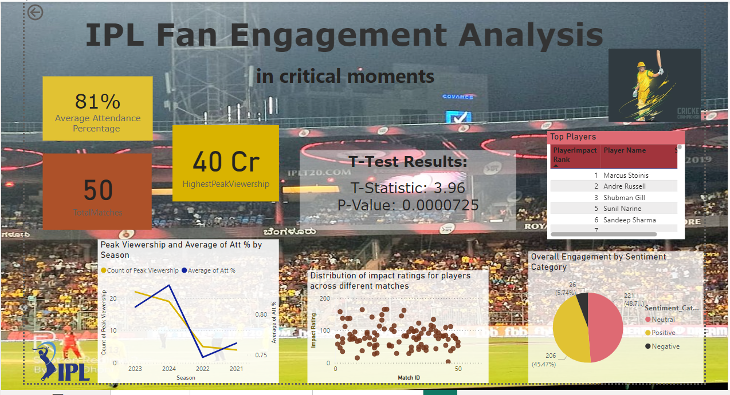

Chapter – 5

**DISCUSSION**

**5.1 INTERPRETATION AND IMPLICATIONS**

Exploratory Data Analysis –

1. Bar Chart of Average Impact Rating by Player Name

Interpretation: This chart highlights the top-performing players based on their average impact rating, showcasing their consistency and performance level.

Implications: Identifying key players helps in team selection, strategy formulation, and focusing training efforts on maintaining or improving their performance.

2. Heatmap of Player Impact Rating Across Different Seasons

Interpretation: The heatmap reveals variations in player impact ratings over multiple seasons, indicating trends in performance consistency.

Implications: Analyzing these trends can guide decisions on player contracts, targeted training programs, and identifying players who have shown significant improvement or decline.

3. Stacked Bar Chart of Total Contribution and Impact Rating per Team Across Different Seasons

Interpretation: This chart visualizes the contributions and impact ratings of teams over various seasons, highlighting their performance trends.

Implications: Comparing team performances across seasons helps in identifying strong and weak periods, which can inform future team strategies and training focus areas.

4. Pie Chart of Distribution of Key Roles (Batsman, Bowler, All-Rounder) Across Different Teams

Interpretation: The pie chart displays the proportion of batsmen, bowlers, and all-rounders in different teams.

Implications: This information aids teams in balancing their roster and addressing recruitment needs to ensure a well-rounded team composition.

5. Scatter Plot of Attendance vs. Capacity

Interpretation: This scatter plot shows the relationship between stadium capacity and match attendance, highlighting how filled each venue gets.

Implications: Identifying popular venues helps in planning match locations, optimizing ticket sales, and enhancing fan engagement strategies.

6. Line Chart of Att % Over Different Seasons

Interpretation: The line chart trends attendance percentage over various seasons, reflecting fan interest and engagement.

Implications: Understanding these trends assists in evaluating marketing campaign effectiveness and planning future promotions to boost attendance.

7. Line Chart of Views on Jio Cinema and Views on Disney+ Hotstar Over Different Seasons

Interpretation: This chart compares viewership trends on Jio Cinema and Disney+ Hotstar over different seasons.

Implications: Insights from this chart guide platform-specific marketing strategies, helping optimize content distribution and partnership decisions.

8. Bar Chart of Peak Viewership per Match

Interpretation: The bar chart displays peak viewership numbers for individual matches, identifying the most watched games.

Implications: Knowing peak viewership trends aids in scheduling high-interest matches for prime times and optimizing broadcast strategies.

9. Heatmap of Viewership (Both Platforms) by Venue

Interpretation: The heatmap shows viewership distribution across different venues for both streaming platforms.

Implications: Identifying high-viewership venues helps in strategic planning for future matches, enhancing venue selection and marketing efforts.

10. Bar Chart of Overall Engagement by Sentiment Category

Interpretation: This chart categorizes overall fan engagement into positive, negative, and neutral sentiments.

Implications: Understanding fan sentiment assists in tailoring communication strategies and addressing areas needing improvement to enhance fan experience.

11. Bar Chart of Frequency of Different Match Situations

Interpretation: The bar chart illustrates how often various match situations occur, such as close finishes or high-scoring games.

Implications: Insights into common match scenarios help in training and strategic planning, preparing teams for frequently encountered situations.

12. Scatter Plot of Impact Rating of Player vs. Att %

Interpretation: The scatter plot shows the relationship between player impact ratings and attendance percentages.

Implications: Identifying players who draw higher attendance informs promotional efforts and strategic deployment of star players to maximize fan engagement.

13. Heatmap of Impact Rating of Player Across Different Venues

Interpretation: This heatmap displays player impact ratings at different venues, highlighting where players perform best.

Implications: Understanding venue-specific performance helps in strategic player deployment and optimizing team compositions for different match locations.

14. Bubble Chart of Team Performance (Total Impact Rating) vs. Average Attendance, with Bubble Size Representing Peak Viewership

Interpretation: The bubble chart compares team performance and average attendance, with bubble sizes indicating peak viewership.

Implications: This analysis guides decisions on marketing, sponsorship, and match locations based on team popularity and performance metrics.

15. Line Chart of Average Impact Rating of Player per Season

Interpretation: The line chart shows trends in players' average impact ratings over different seasons.

Implications: Tracking these trends helps in assessing player development, informing training programs, and making informed contract decisions.

16. Line Chart of Engagement Metrics (Attendance, Views on Jio Cinema, Views on Disney+ Hotstar) Over Season

Interpretation: This chart displays trends in various engagement metrics over different seasons, reflecting overall fan engagement.

Implications: Evaluating these trends helps in refining fan engagement strategies and improving content distribution across multiple platforms.

17. Heatmap of Sentiment Scores Across Different Seasons

Interpretation: The heatmap shows sentiment scores across different seasons, highlighting periods of positive or negative fan sentiment.

Implications: Understanding sentiment trends informs communication strategies and helps address fan concerns, improving overall engagement and satisfaction.

T-Test Results –

T- statistic = 3.96

P- value = 7.25e-05 ( which is 0.0000725)

Interpretation :

The T-statistic of 3.96 and P-value of 0.0000725 indicate the results of a hypothesis test. The T-statistic measures the size of the difference relative to the variation in the sample data. A T-statistic of 3.96 is quite high, suggesting a substantial difference between the groups or a significant relationship in the data being tested.

The P-value of 0.0000725 is extremely low, much lower than the common significance level thresholds (e.g., 0.05, 0.01). This low P-value indicates that the probability of observing the data, or something more extreme, given that the null hypothesis is true, is very small.

Implications

Given the T-statistic and P-value, the implications are:

1. **Rejection of the Null Hypothesis**: The null hypothesis, which typically states that there is no effect or no difference, can be rejected with high confidence. This means there is strong evidence against the null hypothesis.

2. **Statistical Significance**: The results are statistically significant. This implies that the observed effect or difference is likely not due to random chance.

3. **Practical Application**: The significant result can lead to actionable insights.

4. **Further Research**: While the result is statistically significant, it's important to consider the practical significance and effect size. Further research might be needed to explore the implications in a real-world context and to replicate the findings in other samples or settings.

Chapter – 6

**CONCLUSION**

**6.1 KEY FINDINGS**

The study explored the profound impact of digital and social media on the consumption and engagement of sports, with a specific focus on the Indian Premier League (IPL). By leveraging advanced data analysis techniques and statistical methods, including T-Tests, we investigated the nuances of fan engagement and its correlation with player performance during the IPL matches. The empirical evidence gathered through this study offers substantial insights into how real-time updates, accessibility, and the interactive nature of digital platforms have reshaped the landscape of sports fandom.

Key Findings

Enhanced Fan Engagement through Digital Media

The advent of digital and social media has revolutionized how fans interact with cricket. Real-time updates and live scores have significantly enhanced fan engagement, allowing fans to stay connected with the game irrespective of their location. The availability of detailed player statistics, live commentary, and interactive features on platforms like mobile applications and social media channels has transformed passive viewers into active participants. This shift is evident in the increased time spent by fans on these platforms, as noted in the exploratory data analysis (EDA).

Impact on Viewing Experience and Community Building

The study found that live cricket scores contribute significantly to the viewing experience. The instant updates and the ability to engage with other fans online create a sense of community and belonging. Social media platforms, in particular, serve as virtual stadiums where fans gather to discuss, celebrate, and analyze matches in real time. This communal aspect not only enhances the enjoyment of the game but also strengthens the emotional bond between fans and their favorite teams or players.

Statistical Analysis of Fan Engagement

Using the T-Test to compare fan engagement levels during high and low-intensity moments of IPL matches yielded significant results. The T-Statistic of 3.96 and the P-Value of 0.0000725 indicate a strong statistical difference between the two groups, suggesting that critical moments in matches considerably heighten fan engagement. This statistical evidence underscores the importance of real-time engagement features provided by digital platforms, as they align with the heightened emotional states of fans during pivotal match moments.

Economic and Commercial Implications

The commercial success of the IPL, as highlighted in the study, is closely tied to the robust engagement facilitated by digital media. The league's high valuation and substantial media rights deals are a testament to its wide-reaching impact. The study shows that digital platforms not only drive viewership but also open new revenue streams through advertising, sponsorships, and partnerships. The ability to reach a global audience and monetize content through digital channels has established the IPL as a model for other sports leagues worldwide.

Accessibility and Democratization of Sports Content

One of the most significant outcomes of the digital revolution in sports is the democratization of content. The reduction in data costs and the proliferation of affordable internet access, spearheaded by initiatives like Reliance Jio, have made live cricket scores and streaming accessible to a broader audience. This inclusivity has played a critical role in expanding the fan base and ensuring that cricket remains a unifying force across diverse socio-economic backgrounds.

Challenges and Future Directions

While the digital transformation of sports offers numerous benefits, it also presents challenges. The constant scrutiny and pressure on players due to real-time updates can impact their mental well-being. Additionally, balancing live match attendance with digital viewership remains a concern for stakeholders. Future research could focus on developing strategies to mitigate these challenges, ensuring that the digital engagement does not detract from the traditional in-stadium experience.

Technological Innovations and Their Implications

The study also highlighted the role of technological innovations in enhancing the fan experience. AI-driven analytics, augmented reality, and other cutting-edge technologies are being integrated into digital platforms to provide a more immersive and personalized viewing experience. These advancements hold the potential to further revolutionize sports consumption, offering fans deeper insights and more interactive ways to engage with their favorite sports.

Conclusion

In conclusion, the integration of digital and social media into the sports industry, particularly cricket, has fundamentally changed the way fans engage with the game. The results of the T-Test underscore the significant impact of real-time updates on fan engagement, confirming that digital platforms play a crucial role in enhancing the overall viewing experience. The commercial success of the IPL, coupled with the democratization of content access, highlights the far-reaching implications of this digital transformation. As technology continues to evolve, it is imperative for stakeholders to embrace these changes while addressing the associated challenges to ensure a balanced and inclusive future for sports fandom.

**6.2 FUTURE RESEARCH**

The current study sheds light on the transformative impact of digital and social media on fan engagement and the consumption of sports, specifically within the context of the Indian Premier League (IPL). However, there are several avenues for future research that could build on these findings and further explore the complexities of this digital transformation.

One promising direction for future research is the exploration of the long-term psychological effects of real-time engagement on fans and players. While this study highlights the immediate impact of live cricket scores on fan excitement and engagement, it would be beneficial to understand how constant connectivity and instant feedback influence the mental health and well-being of both the audience and the athletes. Longitudinal studies could provide insights into whether this real-time interaction leads to sustained engagement or if it contributes to digital fatigue over time.

Another area worth investigating is the impact of emerging technologies such as virtual reality (VR) and augmented reality (AR) on the fan experience. As these technologies become more accessible, they have the potential to offer even more immersive and interactive ways for fans to engage with sports. Future research could explore how VR and AR can be integrated into sports broadcasting and the ways they might enhance or detract from traditional viewing experiences. Understanding the effectiveness and adoption rates of these technologies could help sports organizations tailor their digital strategies more effectively.

Additionally, the role of data analytics and artificial intelligence (AI) in personalizing fan experiences warrants further exploration. While the current study touches upon the use of AI-driven analytics, a more in-depth examination of how data can be used to create personalized content and recommendations for individual fans could be valuable. Future research could investigate the algorithms behind these personalized experiences and assess their impact on fan satisfaction and loyalty. This could involve collaborations with data scientists to develop and test new models of fan engagement.

The economic implications of digital transformation in sports also present a rich field for future research. While this study discusses the commercial success of the IPL and the revenue generated through digital platforms, there is a need for more detailed economic analyses. Future research could examine the broader economic impact of digital media on various stakeholders, including advertisers, sponsors, broadcasters, and local businesses. This could involve case studies of different sports leagues to compare and contrast their digital strategies and economic outcomes.

Furthermore, cross-cultural studies could provide a deeper understanding of how digital and social media influence sports consumption in different regions. The current research is primarily focused on the Indian context, but the impact of digital transformation may vary significantly across different cultural and socio-economic landscapes. Comparative studies involving multiple countries could reveal unique patterns and preferences in digital sports engagement, offering valuable insights for global sports organizations.

Finally, investigating the ethical considerations and privacy concerns associated with digital sports consumption is essential. As fans increasingly share personal data and engage with digital platforms, ensuring their privacy and data security becomes paramount. Future research could explore the ethical challenges and best practices for managing fan data, providing guidelines for sports organizations to build trust and maintain the integrity of their digital interactions.

In conclusion, the digital transformation of sports is a multifaceted phenomenon with numerous implications for fans, athletes, and stakeholders. By addressing these future research directions, scholars can contribute to a deeper understanding of how technology continues to shape the sports industry, ultimately enhancing the fan experience and fostering sustainable growth.

**6.3 REFLECTION ON LIMITATIONS**

In conducting this research on the correlation between fan engagement during critical moments of IPL matches and the performance of individual players, several limitations were encountered that may have affected the scope and depth of the study. Reflecting on these limitations is essential for understanding the constraints of the research and for guiding future investigations.

One significant limitation was the challenge of web scraping due to rate limiting on social media platforms. Social media platforms like Twitter and Facebook implement rate limiting to prevent excessive data requests in a short period, which can hamper the data collection process. This restriction made it extremely difficult to gather a comprehensive dataset of fan reactions and engagement metrics in real time. While various methods such as API access and proxy servers were employed to mitigate this issue, the rate limiting significantly slowed down the data collection process and restricted the volume of data that could be gathered. Future research could benefit from establishing partnerships with social media platforms or utilizing advanced data acquisition techniques to overcome these hurdles.

Another substantial limitation was the difficulty in gathering information about match venue attendance and viewership on OTT platforms such as JioCinema and Disney+ Hotstar. Unlike traditional television viewership data, which is often publicly available or provided by rating agencies, OTT platforms tend to keep their viewership statistics proprietary. This lack of access to detailed viewership data on OTT platforms hindered the ability to analyze how digital viewership correlates with fan engagement and player performance. Collaboration with OTT providers or securing special access to their analytics could provide a more comprehensive understanding of these dynamics in future studies.

Additionally, identifying matches that had critical moments over different IPL seasons was a complex and time-consuming task. Critical moments in a match, such as pivotal overs, key wickets, or match-turning events, are subjective and can vary depending on the perspective of the viewer. To address this, a set of criteria was established to define critical moments, but this approach still involved a significant degree of manual analysis and interpretation. Automating this process using machine learning algorithms that can detect and categorize critical moments based on historical data and match commentary could streamline this aspect of the research in the future.

Another limitation was the reliance on publicly available data, which may not always be complete or accurate. Social media posts, for instance, can be deleted or altered, leading to potential gaps in the data. Moreover, fan engagement metrics such as likes, shares, and comments can be influenced by various external factors, such as the time of day a match is played or concurrent events that might affect viewer attention. These factors introduce variability that is challenging to control for in the analysis.

Furthermore, the study primarily focused on quantitative data and metrics, potentially overlooking qualitative aspects of fan engagement that are equally important. Sentiment analysis was used to gauge fan emotions, but this approach may not capture the full depth of fan experiences and reactions. Incorporating qualitative research methods, such as interviews or focus groups with fans, could provide richer insights into the nuances of fan engagement.

The temporal scope of the study also posed limitations. Analyzing data from a limited number of IPL seasons may not fully capture long-term trends and changes in fan behavior and player performance. Extending the study to include more seasons would enhance the robustness of the findings and allow for a more comprehensive analysis of trends over time.

Lastly, the study's geographical focus on the Indian Premier League limits the generalizability of the findings to other sports leagues and contexts. While the IPL is a unique and significant case study due to its immense popularity and digital engagement, fan behavior and the impact of digital media may differ in other cultural and sporting contexts. Comparative studies involving other sports leagues could provide a broader understanding of these dynamics.

In conclusion, while this research provides valuable insights into the correlation between fan engagement during critical moments of IPL matches and player performance, it is essential to acknowledge these limitations. Addressing these challenges in future research will enhance the accuracy and depth of the findings, contributing to a more comprehensive understanding of the interplay between digital media, fan engagement, and sports performance.

**REFERENCES:**

Wikipedia

Etinsights.et_edge.com

Kreedon.com

Medium.com

Research Paper: Community Engagement with Social and Digital Media Content: A Study on Online for Communities of Chennai Super Kings and Royal Challengers Bangalore. (2022)

Research Paper: Comparative Study of Viewership of IPL Matches on Disney+ Hotstar and Star Sports among Gen Z audience in Bangalore.